STCU PROJECT 2121-Techncal report for stage 1 T01

Single Crystal Growing and Experimental Checking of the Basic Principles of the Approach to CsI:Tl Crystal Improvement.

Summary
The goal of Stage 1 of the project is the improvement of the CsI(Tl) crystal quality according to their application with photodiodes (PD) as light receivers. For this purpose, it is necessary, first of all, to determine the optimum activator concentration in CsI:Tl crystals for their application with PD.
Two types of the crystals have been grown. The thermal growth conditions of these crystals have been compared.

The spectrometric properties, afterglow and radiation resistance of the grown crystals have been studied. It has been shown that the afterglow of the second type crystals is lower, the radiation resistance is higher and the light yield and energy resolution are not worse.

The more precise definition of the optimum activator concentration has been done for the second type crystals. It has been shown that the light yield dependencies and R of the crystals of both studied types do not differ significantly. The optimum thallium concentration for γ-quanta registration with the “CsI:Tl crystal-silicon photodiode” pair (type 2) has been evaluated as 0,09 ≤ C_{Tl} ≤ 0,15 mole% when the low afterglow and good radiation resistance are provided.

The α-output dependence and α⁄γ-ratio value as a function of activator concentration have been studied for the crystals of both types. It has been shown that the dependence exists. It has been proven that the α/γ-ratio depends on the activator concentration at any really applied signal formation time. The received results have been compared with known theoretical models. Both of them are bad. According to the representations……it has been shown that the activator center saturation model corresponds better to the experimental data.

The contemporary conceptions of crystal surface stability and mechanical treatment influence on it have been considered. The method of surface treatment has been proposed, combining with the packing……it provides the very high parameters. The analysis of measurement result reproducibility for the light yield and energy resolution has been carried out. It has been shown that under the identical thermal crystal growth conditions, similar mechanical treatment conditions and surface polishing with (110) indexes, the spectrometric properties are reproducible if the measurements are carried out taking into account the surface-adjacent layer relaxation.

The pre-conditions for the successful development of the high sensitive spectrometric γ-detectors have been provided on the basis of the “CsI:Tl scintillator-silicon photodiode” system.

Summary | PAGE 1
Content of technical report for stage 1 | PAGE 2
Introduction | PAGE 2
Technical approach | PAGE 3
1 Brief review of literature data on the scintillation mechanism in CsI(Tl) crystals | PAGE 4
Emission centers in CsI(Tl) crystals | PAGE 4
1.2 Energy transfer to the emission centers in CsI(Tl) | PAGE 5
2 Experimental checking of the basic principles of the approach to CsI:Tl crystal improvement | PAGE 8
2.1 Characteristic features of crystal growth | PAGE 8
2.2 Radiation resistance of CsI(Tl) crystals | PAGE 10
2.3 Millisecond crystal afterglow | PAGE 12
2.4 Spectrometric crystal properties | PAGE 12
2.5 Activator concentration influence on scintillation response | PAGE 14
2.6 Comparison of the experimental results with theoretical models | PAGE 16
2.7 Improvement of the surface treatment methods | PAGE 18
Conclusions | PAGE 20
References | PAGE 20

Introduction
The goal of the project is the development of high-sensitivity spectrometric gamma-detectors on the base of the “scintillator – photodiode” system. To solve such complicated problem, some progress should be achieved in several directions, such as 1) improvement of the CsI(Tl) crystals quality in view of their application with PD used as light receivers; 2) improvement of the crystal treatment methods; 3) optimization of the light collection conditions, shape and dimensions of the scintillator; 4) development of charge-sensitive amplifiers with improved input noise and dynamical characteristics. The first two of these directions correspond to different, but closely related steps in scintillator producing. To evaluate the required concentration of the activator in CsI(Tl) crystals for their application with PD is the idea of the first stage of the project.

It is known, the spectral composition of RL of CsI(Tl) crystals essentially depends on the activator concentration as well on the content of associate impurities in the raw material. In particular, the presence of sodium and intrinsic crystal lattice defects leads to the increase of luminescence intensity in the short-wave region of the spectrum due to yellow band [1]. However, it is extremely undesirable for the crystal application together with silicon PD. Intrinsic crystal lattice defects are distributed in the detector volume non-uniformly, and in most cases their quantity is larger within the crystals’ surface-adjacent layers due to plastic deformation induced by mechanical treatment [2]. As for the negative influence of the impurities, there are fairly compete data, which show that the contribution of impurity luminescence can be reduced by thallium concentration increasing (C_{Tl} ). For the contribution of intrinsic point defects, such information is not available. However, by analogy it can be assumed that increase of C_{Tl} may lead to reducing of these defects contribution, too. Non-uniform distribution of intrinsic point defects inside the crystal results in non-linear dependence of the specific light output on the energy and, consequently, in worsening of one of the main detector parameter – its energy resolution R [3]. Thus, the increasing of C_{Tl} in the crystals is the necessary condition to obtain efficient detectors for “CsI(Tl) - PD” system.
The required activator concentration can be specified only approximately since the known light output dependences on C_{Tl} obtained by different authors differ, and the character of these dependences is defined by the crystal growth technique. Therefore, it is necessary to determine the dependences of the light yield and energy resolution on C_{Tl} for particular growth technique and crystal treatment method and to check them after final correction of the technological process. Analogous dependences for the α/γ-ratio will give important additional information on the optimum C_{Tl} value. The analysis of the time dependence of the said ratio will give the necessary data as for the state of the crystal surface and the influence of the method of surface treatment on the detector quality.
Technical approach
As a matter of principle the technical approach and strategy are well known and based on the previous practical experience, particularly, on the ability to forecast the crystal properties depending on the conditions of their production. Recently, it has been evident that the main spectrometric parameter of the material (the intrinsic energy resolution (R_{С}) ) is closely connected with the scintillation response disproportionality (SRD) of the exciting particle energy. In turn, SRD for such material as CsI:Tl is closely connected with kinetic parameters of scintillation [1]. Particularly, it was shown [2] that there is the opportunity of SRD and R_{С} decreasing for these crystals under the condition that afterglow (AG) reduces.
Now the effective technological methods of AG reduction have been known, however, for the majority of them the reduction of the crystal radiation resistance is assumed. Since the standard method of AG reduction is the application of co-activators (such as, e.g., CO₃^{2–}, Cl–, Eu²⁺ dopant impurities), in this case the problem of the crystal growth method correction appears for both the necessary activator and impurity distribution in the boule volume. On the other hand, it is known that the optimum thallium concentration in the crystals depends on the crystal growth techniques substantially. So automatically, the change of the techniques assumes the more precise definition of the data as for the optimum thallium concentration.
The latter is possible only if the identity of the conditions of surface mechanical treatment is adhered strictly, which, in turn, provides the application of single crystal pieces, strictly oriented along the crystallographic axes. In connection with the fact that after mechanical treatment the layer of the increased conversion efficiency exists near the surface and its depth is up to 10-30μm [1, 3], all measurements of the light yield and energy resolution have been done after the layer relaxation. Such approach gives the opportunity to obtain the reproducible results and minimizes the scatter of data.
The CsI:Tl crystals, grown by the automated method of pulling on a seed with replenishment by the melted raw material, have been studied [4]. To grow the crystals, the unique technological equipment has been used which allows to obtain the single crystals with the predetermined crystallographic orientation and uniform distribution of the activator. The scintillators measuring ∅25×20, or 10×10×10 mm were cut out from crystalline boules of 240 mm in diameter and of 360 mm in height, with uniform (± 5%) distribution of thallium.
1 Brief review of literature data on the scintillation mechanism in CsI(Tl) crystals

1.1 Emission centers in CsI(Tl) crystals
The question about the nature of emission centers in the studied crystals has been still discussive. It is known for certain that the activator enters the CsI lattice in form of Tl⁺, substituting the Cs⁺ matrix cation in the regular lattice site. The Tl⁺ cations absorb the light in the CsI matrix transparent region. The absorption spectrum has several maxima, which traditionally are labeled as A-, B-, C-, D-bands [5]. The characteristic luminescence of the CsI(Tl) crystal with the maximum at 550nm appears and comes out most intensively during the excitation in the longest-wave A-absorption band. In addition to this luminescence in the absorption bands, the other luminescence centers of the activator as well as nonactivator nature are excited. As an example, basing on work [6], the luminescence and excitation spectra of the CsI(Tl) crystal, when thallium concentration is equal to C_{Tl} = 2∙10^{–1} %, are given in Fig.1.
Fig.1. The luminescence and excitation spectra of the CsI(Tl) crystal at C_{Tl} = 2∙10^{–1} %.
Fig.2. The radioluminescence spectra of CsI(Tl) crystals at C_{Tl} = 5∙10^{–2} (1); 7∙10^{–2} (2) and 1,1∙10^{–1} mass % (3). The absorption spectra (5,6) cut out of the upper (5) and (6) bottom parts of the boule.

The luminescence at 550nm is used in scintillation technique, especially during the signal registration with the help of silicon photodiodes (PD). This broad luminescence band is nonelementary and consists of at least three bands with maxima at 480, 550 and 590nm [7]. It should be noted that the intensity and the shape of this band depend on thallium concentration (C_{Tl}) in the crystal [8]. Our data about changes in radioluminescence spectra of CsI:Tl crystals with the CTl increase are given in Fig.2. It is visible that when the activator concentration increases the luminescent maximum shifts to the long-wave region.

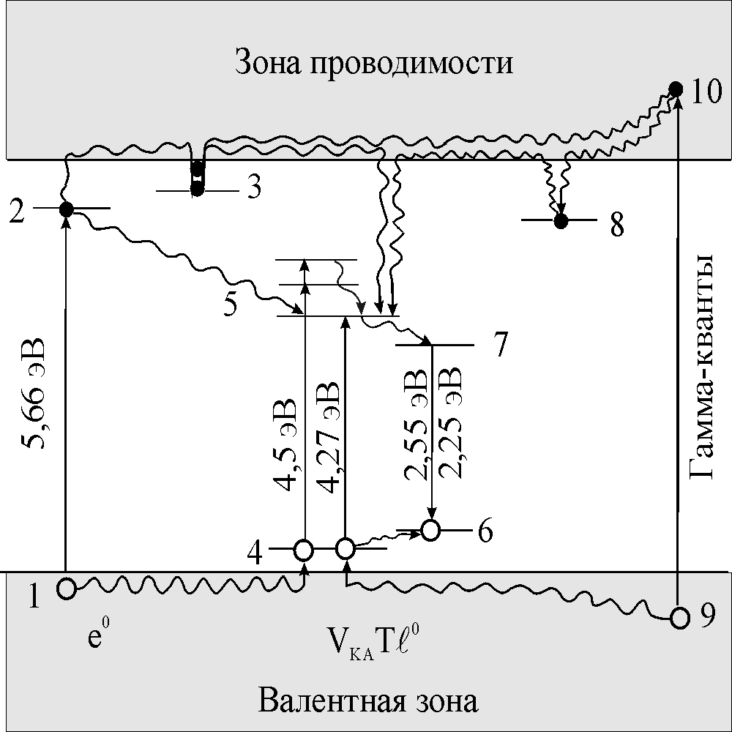
Unlike the exciton excitation, at γ-excitation the scintillation decay time does not contain the fast component and has the form of a superposition of two slow components. It means that two capture centers participate in the process: a shallow trap for the electrons of the type similar to that of the exciton excitation and a trap of another type with a little larger depth (9→10, 10→8→7, 10→3→7, 9→4). Conduction band

ɣ-quanta

Valence band

Fig.4. The energy scheme of the scintillation process in CsI(Tl) crystals corresponding to exciton- and γ-excitation.

As follows from the above-mentioned results, the duration of the spontaneous transfer of the V_{KA}Tl° luminescence excitation center into Tl⁺ ground state could be nanosecond at room temperatures because the decay time reduces exponentially when the temperature increases. So, if there is the hole recombination luminescence at the temperatures above 230-250K and V_{KA}Tl⁰ pair appears when V_{K} center is located in the Coulomb field of the Tl⁰ center, the duration of the γ-scintillation in CsI:Tl crystals should be much more less than the real observed one. On the other hand, the mechanism of the electron recombination luminescence [18] determines the existence of shallow electron traps, which quantity is large and should be comparable with the concentration of V_{K} centers to obtain the high scintillation output. Most probably, the electrons are trapped by Tl⁺-ions, followed by the Tl⁰ formation. And in such case V_{KA…….}Tl⁰ pairs would appear not on one Tl⁺-ion but on two ions, forming the excimer-like state, which leads to the decay time increasing as it is in KCl:Tl [19], or the donor-acceptor pairs [16].
The assumption that the energy transfer mechanism may be connected with ERL also was made in [20]. It was based on the fact of presence of 3.09 eV band in the scintillation light (intrinsic luminescence of Tl⁺ center was quenched incompletely at 300 K). The authors suppose that holes may be captured on the activator with subsequent formation of Tl⁺.
The possibility of Tl⁺⁺ formation was brought into question in monograph [16]. It is supposed that the lower energy level of this center is located within the valence band very close to its upper boundary. At present, according to the results of ODMR study [21] it has been shown convincingly that holes are localized in the form of V_{KA} in CsI(Tl) crystals. ERL with these centers would lead to creation of a bound exciton, and further the processes would develop according to the scheme described above. Since at room temperature the glow at 3.09 eV was quenched considerably, in [20] it was concluded that for CsI(Tl) crystals HRL is predominating, and being present, ERL contributes insignificantly.

Based on the data from literature and carried experiments we suggest the following method of the mirror-reflective crystal surface obtaining. We would remind, that CsI crystals have no cleavage planes and the surface of the studied samples is always ready due to mechanical treatment. For other crystals, a cleaved facet can be used as a standard. Perfect surface producing is exclusively difficult problem for CsI crystals. Making no pretence of problem solving in whole, rather evident suggestions can be offered for surface treatment improvement:

- First, the surfaces of CsI:Tl crystals should be prepared qualitatively by the deep grinding and polishing method to eliminate the residual stresses due to mechanical treatment.
- The crystallographic orientation of the treated surface should correspond to (110) indexes, at any rate, for the most important faces, e.g. for the input surface relatively to the incident radiation.
- The real state of the surface layer can be evaluated due to the α/γ ratio. In this case, the crystal can be treated by the similar way, when the activator concentration is not high, and then the α/γ ratio should be measured at once or in a day after the treatment.
- To avoid the negative influence of the spontaneously appeared profile the following procedures should be done taking into account the time factor of the disturbed surface-adjacent layer relaxation. The relaxation lasts for 12-14 days and it is better to place the detector into the dry atmosphere for this time or to protect it with a hydrophobic film. The final measurements of the resolution should be carried out after the surface-adjacent layer relaxation.

To produce the stable polished surface, taking into account the postprocedures of the protecting coating, we suggest the new method of the CsI crystal treatment. The method includes the grinding procedures and the grinding finish treatment with tetraoxysilan. In addition, this method is notable for the partially hydrolyzed tetraoxysilan application which layer is coated with oligoethyl hydride siloxan solution in toluene at 5-10% concentration after 10-12 day exposure. This is just the way of “CsI+PD” assembly sensors were prepared; the test results of them are given in Table 2 and Fig. 9.

Conclusions

On the ground of the obtained results the following conclusions can be done. The full size CsI:Tl crystals (∅250×360mm³), doped with NO₂–-ions, have been grown by the automated method of pulling on a seed with the melted raw replenishment. Their spectrometric properties, afterglow and radiation resistance have been studied. It has been shown that the crystals, which have 0, 09cm¯¹ absorption coefficient in ν₃ maximum of NO₂–-ion absorption band, have the similar light yield and energy resolution in comparison with standard CsI:Tl crystals. The afterglow of the obtained crystals has been reduced by 50% and the radiative resistance has been increased by more than an order of magnitude. To clear up the positive influence of the pointed ions on the scintillation properties of the crystals it is necessary to carry out additional researches.
The analysis of literature data about the activator influence on spectrometric properties of CsI:Tl crystals has been carried out. It follows from this method that the main reason of the differences between various author data is the form of the light yield dependency for α-particles on the thallium content and the fact of the dependency or independency of the α/γ ratio on the activator concentration. The explanation of these differences has been done based on the fact of the temporary increase of the conversion efficiency near the input surface of the scintillator. It has been proved that the α/γ ratio depends on activator concentration at any really applied signal formation times.
.

