Bug report
№1
Summary: on the product card TVs no photo.
1. Open the home page.
2. In the menu go to the “TVS”.
Expected result: the TVs product card have a photo.
Actual result: the product card there is no photo.
Attachment: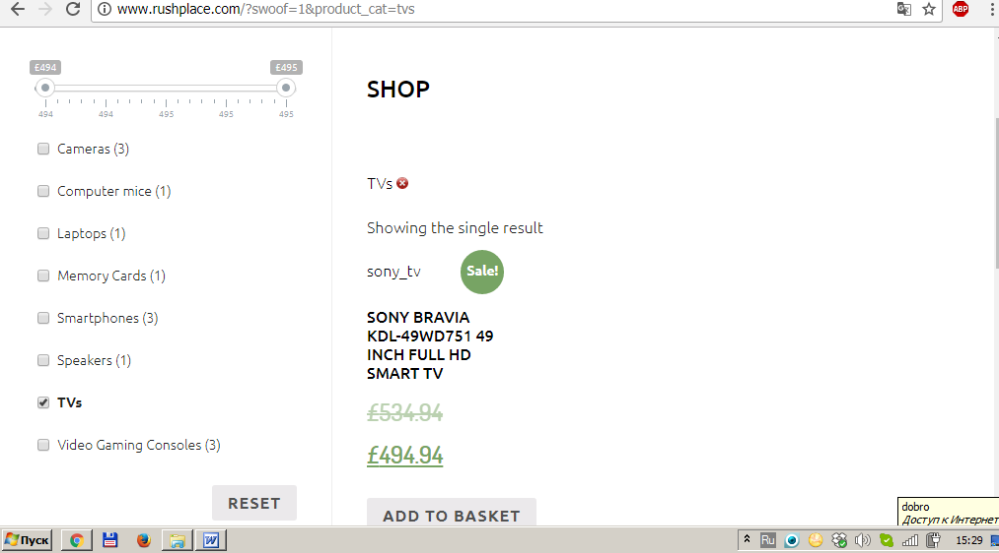
Severity - Customer Experience;
Priority –Medium;
Found on http://www.rushplace.com/?swoof=1&product_cat=tvs ;
Submitted by Plashkevich Alena
Date submitted: 07.10.17

Bug report
№2
Summary: search does not correctly displays the search results.
1.Оpen the home page.
2.Insert the window «Search»: «Cameras»
3.Click: «enter»
Expected result: on the page there is a description of the three product.
Actual result: the page contains the description of a single camera.
Attachment: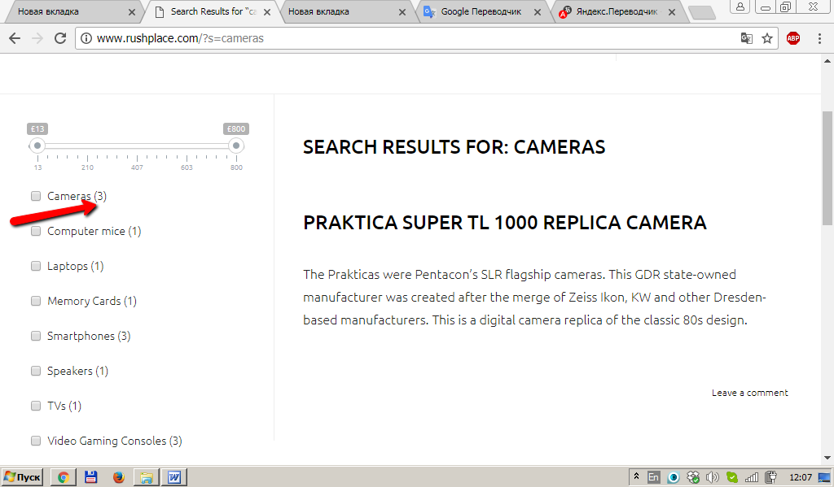
Severity- Customer Experience;
Priority- Medium;
Found on http://www.rushplace.com/?s=cameras
Submitted by Plashkevich Alena;
Data submitted 07.10.17.

Bug report
№3
Summary: search shows “nothing found”, and the item is in stock.
1. Open the home page.
2. In the Search window insert: «memory cards».
3. Click «enter».
4. Repeat steps 2-3 for categories “Computer mice”, “Smartphones”, “ TVs”, “Video Gaming Consoles”;
Expected result: a memory cards is displayed on the page.
Actual result: the page appears “nothing found”.
Attachment: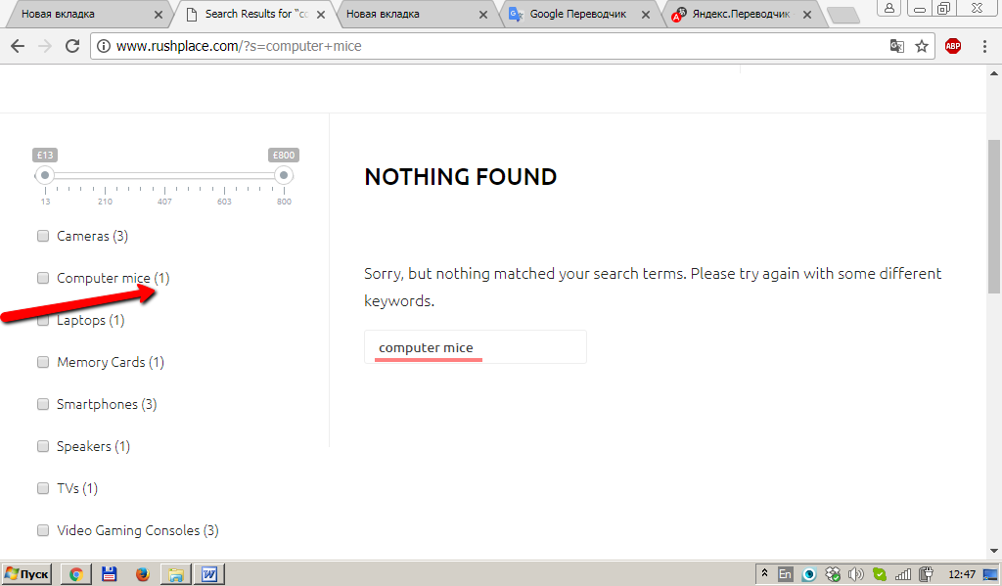SeveSeverity -conversion.
Priority-medium.
Found on http://www.rushplace.com/?s=Memory+Cards
Submitted by Plashkevich Alena;
Data submitted 07.10.17.

Bug report
№4
Summary: in the categories “Computer mice” of spelling error.
1.Open the home page.
2.Select category “Computer mice”
Expected result: the word «mice» should be written «mouse»Attachment: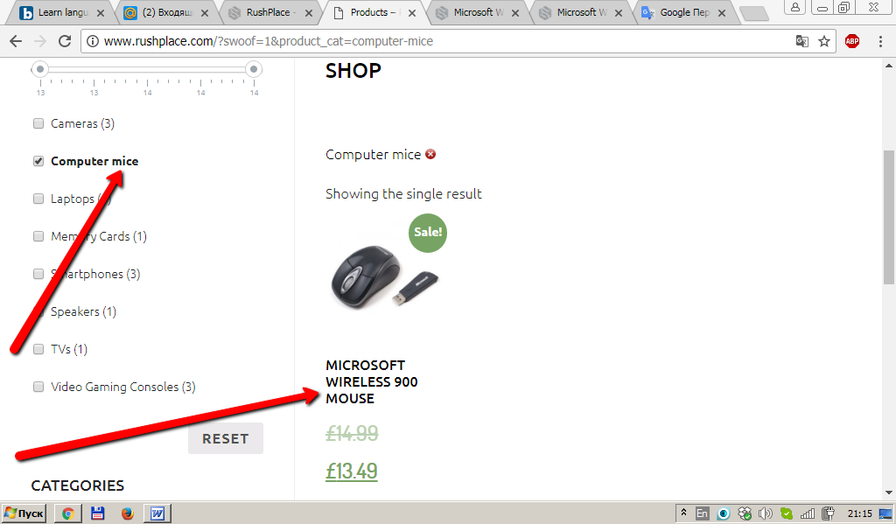
Severity- customer Experience.
Priority-Low
Found on http://www.rushplace.com/?s=computer+mice
Submitted by Plashkevich Alena;
Data submitted 07.10.17.

Bug report
№5
Summary: spelling error in a word “orderby”
1.Оpen the home page.
2.Open the drop-down list «default sorting».
3.Select it in the any place.
Actual result: appears “orderbe”.
“Оrder by” should be written separately.
Attachment: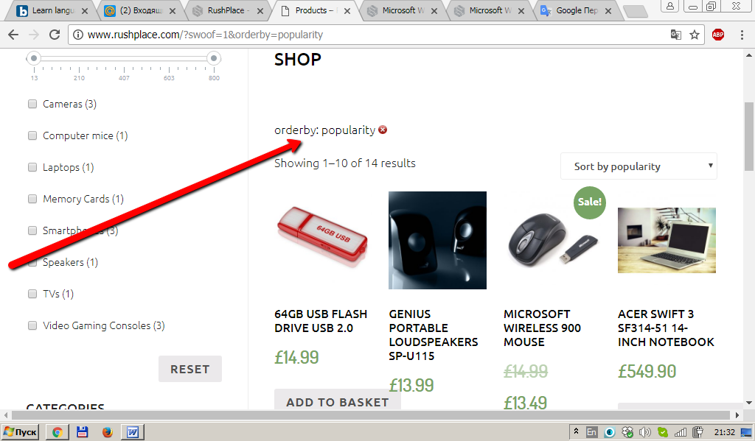

Severity-customer experience
Priority- low
Found on http://www.rushplace.com/?swoof=1&orderby=rating;
Submitted by Plashkevich Alena;
Data submitted 07.10.17.

Bug report

№6

Summary: a logical error in the sentence « Lost your password? Please enter your username or email address. You will receive a link to create a new password via email.»
1.Оpen the home page.
2.Go to the My account page.
3.Click on «Lost your password?»
4.Appears «Lost your password? Please enter your username or email address. You will receive a link to create a new password via email.»
If the user writes only his/her username to where will they receive a link to create a new password via email? Attachment: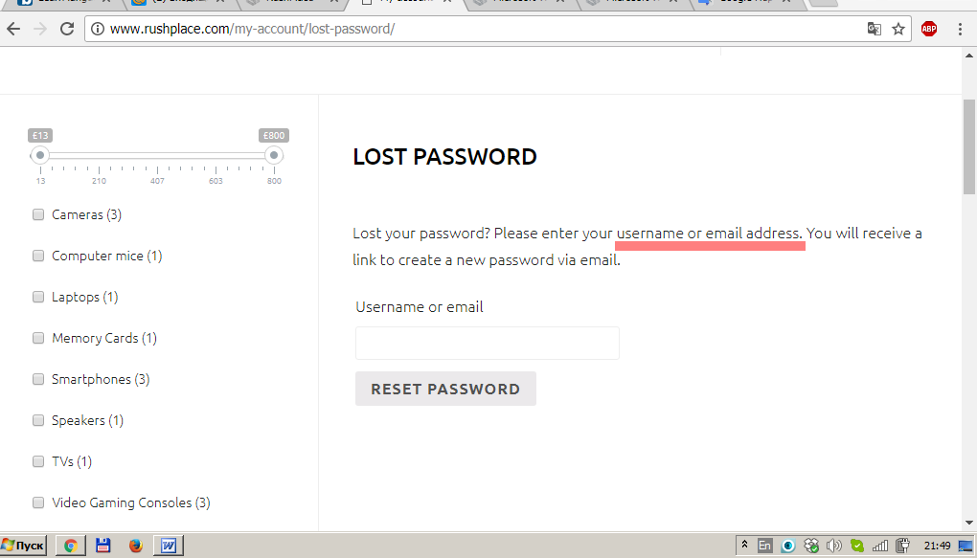

Severity-customer experience;
Priority-medium;
Found on http://www.rushplace.com/my-account/lost-password/
Submitted by Plashkevich Alena;
Data submitted 07.10.17.

