Переводчик: | Боровикова Ульяна Викторовна ©
Оригинал:

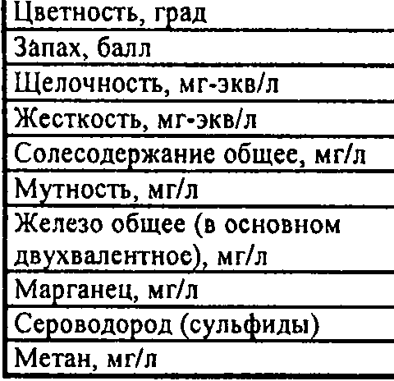

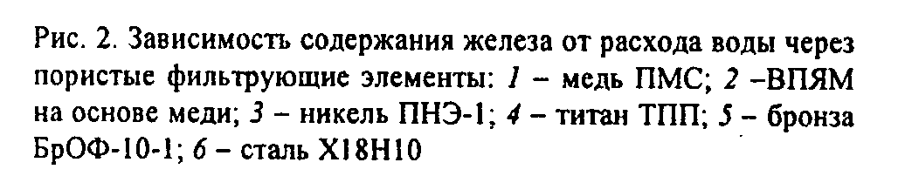

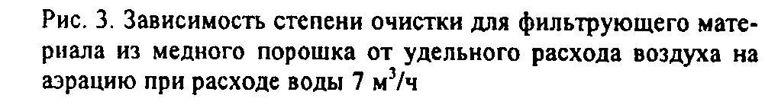
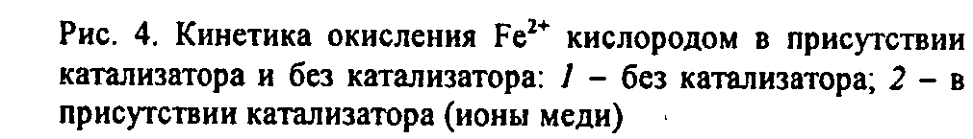
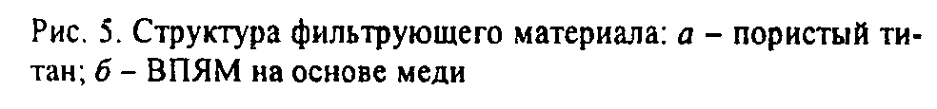

Перевод:
Pic.1 Installation diagram for researching the iron withdrawal from water:
Table 1. Source water characteristics
Indicator name | Value | Sanitary Regulations and Norms

Chromaticity, gradation
Smell, mark
Alkalinity, mg-equ/l
Hardness, mg-equ/l
Salinity, mg/l
Opacity, mg/l
Total Ferrum (mainly bivalent), mg/l
Manganese, mg/l
Hydrogen sulfide (sulphides)
Methane, mg/l

Pic.2 Relation of iron quantity while discharging water via screening filter elements:
1 – copper Polymethylsiloxane; 2 – copper-based highly porous cellular materials; 3 – nickel electrolytic powder-1; 4 – titan powder TPP; 5 – Bronze BROF-10-1; 6 – X18H10 steel.
Pic.3 Relation of purification via copper powder filter material and oxygen discharge intensity for water aeration 7 m³/h
Pic. 4 Kinetics of catalysed and non-catalysed^{Fe2+} oxidation: 1 – non-catalyzed4 2 – catalysed (copper ions)
Pic.5 Filter material structure: a – porous titan; b - highly porous cellular materials
Results of testing of deironing filter material samples
Material name | highly porous cellular materials’ thickness, mm | Ti PPM pore size, µm | Filtrate iron concentration, mg/l

Pic.6 Construction diagram for deironing: 1 - aeration chamber; 2 – aerators; 3 – catalytic load filter;
4 – pressure contact filter; 5 – two-layer porous filter element

