
VS Y-ABC-80 Horizontal Test Bench

Operating Instructions
Shanghai Haidelong Fluid Equipment Manufacturing Co., Ltd.

Notices
Prior to use of this test bench, the user shall carefully read this Operating Instructions, have a full understanding of the Operating Instructions, install, use and maintain this test bench as required, and work on the bench after thorough understanding of various safety measures and operating procedures in order to prevent equipment damages or casualty accidents.
While testing the high pressure valve, the user shall not get close to the tested valve or additionally arrange the protective covers to prevent being injured by the leaked water and air.
Although the contents of this Operating Instructions are carefully checked, please contact with the Company in case of any doubt, incorrect interpretation or omission.
The user shall properly keep this Operating Instructions, and contact with the Company in case of any doubt.

1. General
- Scope of application
The test bench mentioned in this Operating Instruction mainly has the following specification: VSY-B-200-64
- Model meaning
VSY-ABC-80-160
VSY - Hydraulic valve test bench of Shanghai Haidelong Fluid Equipment Manufacturing Co., Ltd.
В - Horizontal clamping type
80 - Maximum aperture of test valve
160 - Highest pressure of the maximum aperture valve seal (mm /64kg)
- Functions and scope of test bench
- Functions of test bench
This test bench is used for strength and seal pressure tests of flanges and straight-through valves and fully conforms to GB/T13927-92 Pressure Testing for General Purpose Valves and ZBJ16006-92 Valve Test and Inspection.
- Test scope (pressure comparison table)
Pressure Comparison Table Required for VSY-ABC-80 Clamping Cylinder
DN  Nominal  Diameter  (DN) |  |  |  | Nominal Valve Pressure (MPa/class)
 |  |  |  | 1.6 |  | 2.5 |  | 40 |  | 64 |  | 10.0 |  | 16.0 |  | 20.0 |  | 25.0 |  | 32.0
 |  |  |  |  |  | 150 |  | 300 |  | 400 |  | 600 |  | 900 |  |  |  | 1500
 |  |  |  | Hydraulic system pressure (booster) (MPa)
in |  | mm |  | PN | PS | PN | PS | PN | PS | PN | PS | PN | PS | PN | PS | PN | PS | PN | PS | PN | PS
1/2 |  | 15 |  | 3.0 | 3.0 | 3.0 | 3.0 | 3.0 | 3.0 | 3.0 | 3.0 | 3.0 | 3.0 | 3.0 | 3.0 | 3.0 | 3.0 | 3.0 | 3.0
1 |  | 25 |  | 3.0 | 3.0 | 3.0 | 3.0 | 3.0 | 3.0 | 3.0 | 3.0 | 3.0 | 3.0 | 3.0 | 4,0 | 3.5 | 5.0 | 4.0 | 6.0
1-1/4 |  | 32 |  | 3.0 | 3.0 | 3.0 | 3.0 | 3.0 | 3.0 | 3.0 | 3.0 | 3.0 | 3,0 | 3.5 | 5.0 | 4.0 | 6.0 | 5.0 | 8.0
1-1/ | 2 | 40 |  | 3.0 | 3.0 | 3.0 | 3.0 | 3.0 | 3.0 | 3.0 | 4.0 | 3.5 | 5.0 | 5.5 | 8.0 | 6.5 | 10.0 | 8.0 | 12.0
2 |  | 50 |  | 3.0 | 3.0 | 3.0 | 3.0 | 3.0 | 5.0 | 5.5 | 8.5 | 8.5 | 12.5 | 13.5 | 20.0 | 17.0 | 25.0
2-1/2 |  | 65 |  | 3.0 | 3.0 | 3.0 | 4.0 | 4.5 | 6.5 | 6.5 | 10.5 | 10.5 | 15.5 | 16.5 | 25.0 | 21.0 | 31.0
3 |  | 80 |  | 3.0 | 4.0 | 4.0 | 6.0 | 4.5 | 9.5 | 10.0 | 16.0 | 16.0 | 24.0 | 20.0 | 31.0
- Operating environment of machines
This machine shall be applied to use in the following actual environmental and operating conditions.
The ambient temperature is within 5°C to 40°C, and the average temperature within 24h shall not exceed 35°C. The relative humidity is within 30% to 95%, and the humidity change shall not cause condensation in principle. The altitude is below 1000m.
The atmosphere has no excessive dust, acid gas, erosion gas and salt.
Environmental changes caused by direct sunlight or thermal radiation of the test beach shall be prevented.
The installation position shall be far away from the vibration source.
The installation position shall be far away from inflammables and explosives.
- Environmental impacts on machines
This machine has no adverse environmental impacts, harmful gas or discharged liquid.
- Test Bench Lifting and Installation
  - Test bench lifting
During lifting with crane:
- Two crown blocks can be used (see Figure 1).
- Two cable wires with different lengths shall be used to respectively lock four lifting holes, the cable wires used for the movable frame should be about 1.5M to 2M longer than that of the hydraulic station depending on the actual size of the bench, it would be best to use the cable wires sleeved with rubber tubes to avoid bench damages. The boom of the machine should be removed or fixed before lifting so as not to damage the machine or people.
- The crane lifting capacity is more than 3t.
- The lifting rope diameter is more than 18mm.
- D-type shackle is more than M22.
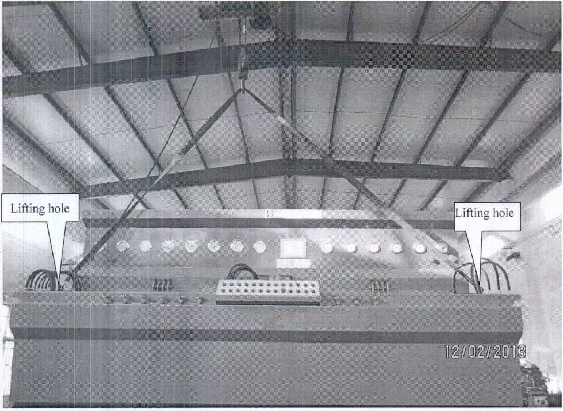
Figure 1. Machine Lifting
  - Machine installation
    - Preparations before installation
The machine shall be installed in accordance with the operating environment specified in Article 1.4.
- The machine shall be installed in the plant area with the lightning protection device.
- The machine shall not be installed on the soft ground. If the machine only can be installed on the soft ground, the piling or similar measures shall be taken to improve the bearing capacity of soil layers, and the machine can be prevented from sinking or tilting.
- In case that the machine has to be installed near the vibration source, trenching or similar measures must be taken around the machine for anti-vibration.

2.3 Power interface and mains
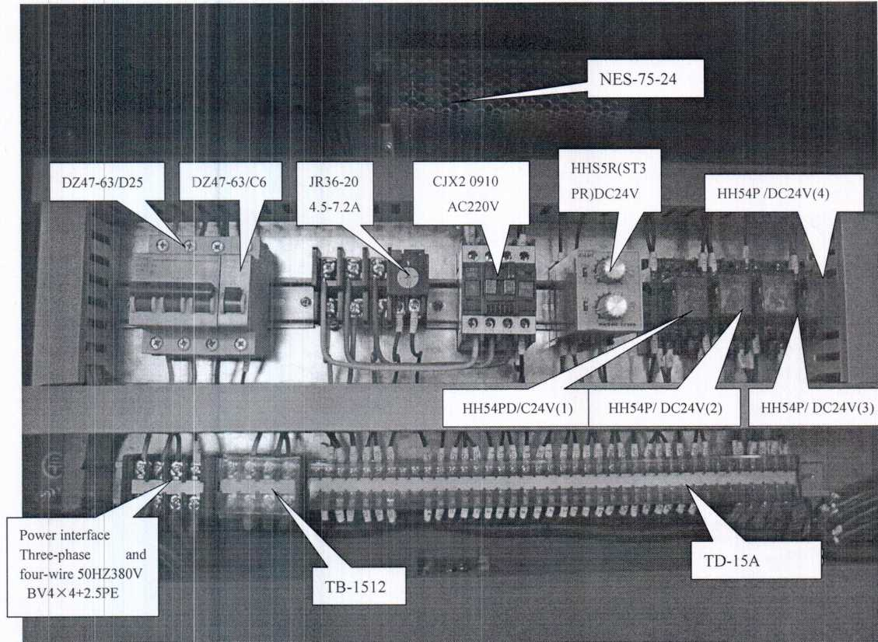
Figure 2
Figure 2 Electrical installation plates
SN |  | Models | Names | Functions
1 |  | TB-1512 | Terminal | Primary circuit connection
2 |  | TD-15 | Terminal | Secondary circuit connection
3 | I | ffl54P/DC24V(l) | Intermediate relay | Oil pump startup
4 | I | iH54P/DC24V(2) | Intermediate relay | High-pressure pump startup
5 | I | 4H54P/DC24V{3) | Intermediate relay | High-pressure pump stop
6 | I | iH54P/DC24V{4) | Intermediate relay | ilff.
 | HHS5R(ST3PR)DC24V |  | Time relay | Reciprocating operation of high-pressure pump
7 | CJX2 (1 )0910DC24V |  | Contactor | Oil pump startup
8 |  | NES-75-24 | DC24 Power supply | Transformer
9 |  | DZ47-63/C6 | Circuit breaker | Circuit Protection
10 |  | DZ47-63/D25 | Circuit breaker | Primary circuit power switch
11

3.1 Wiring diagram

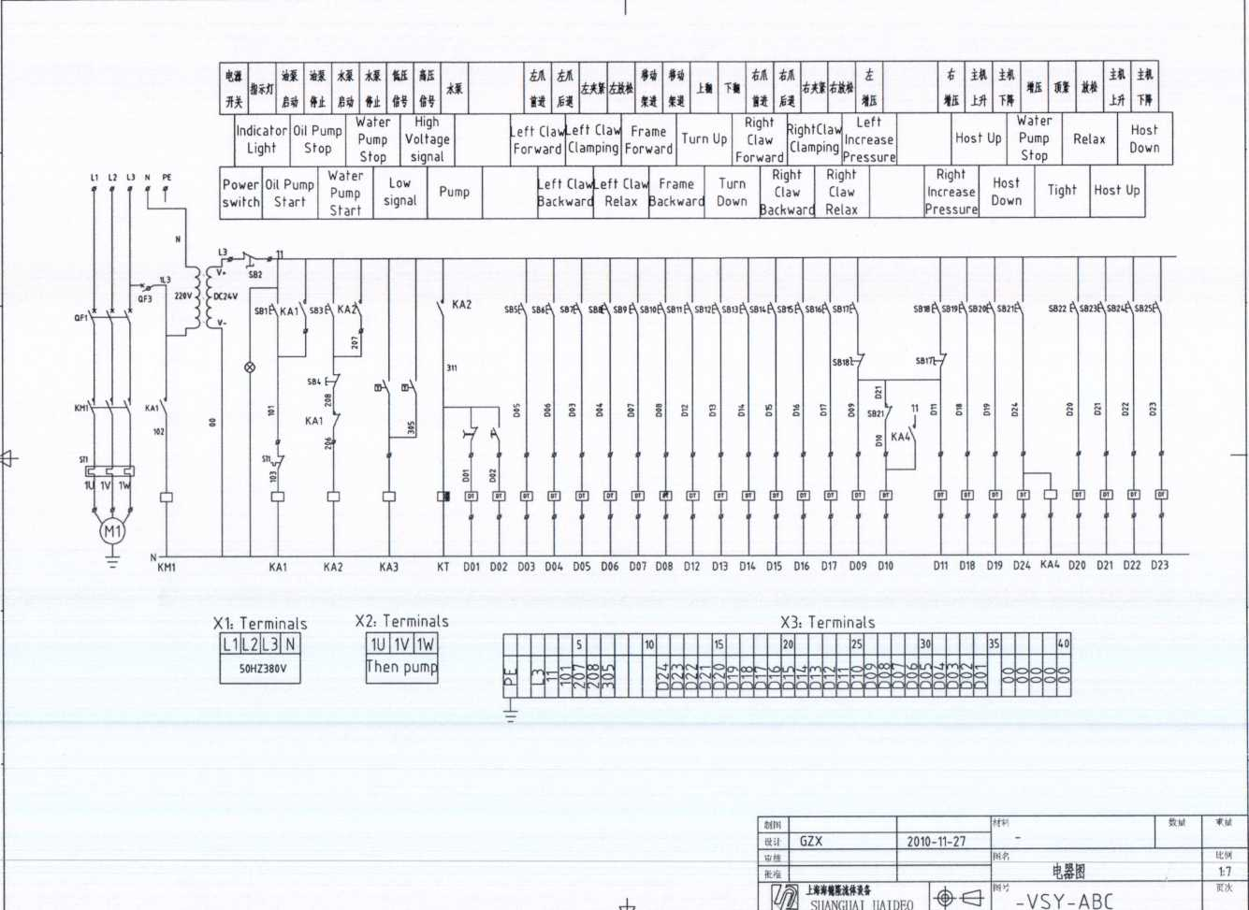
со
0)
—
.SP
Е

- Distribution of hydraulic elements
- Hydraulic schematic diagram
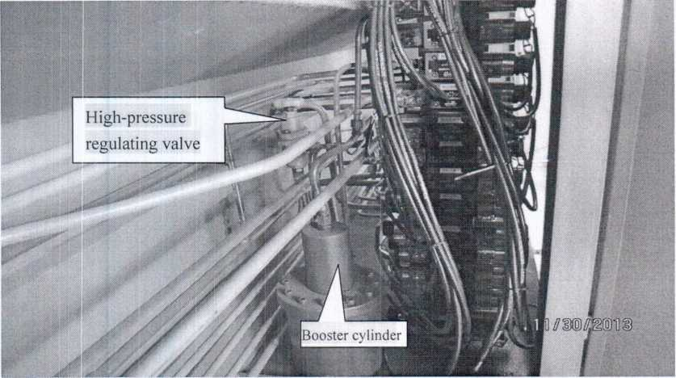
Figure 4
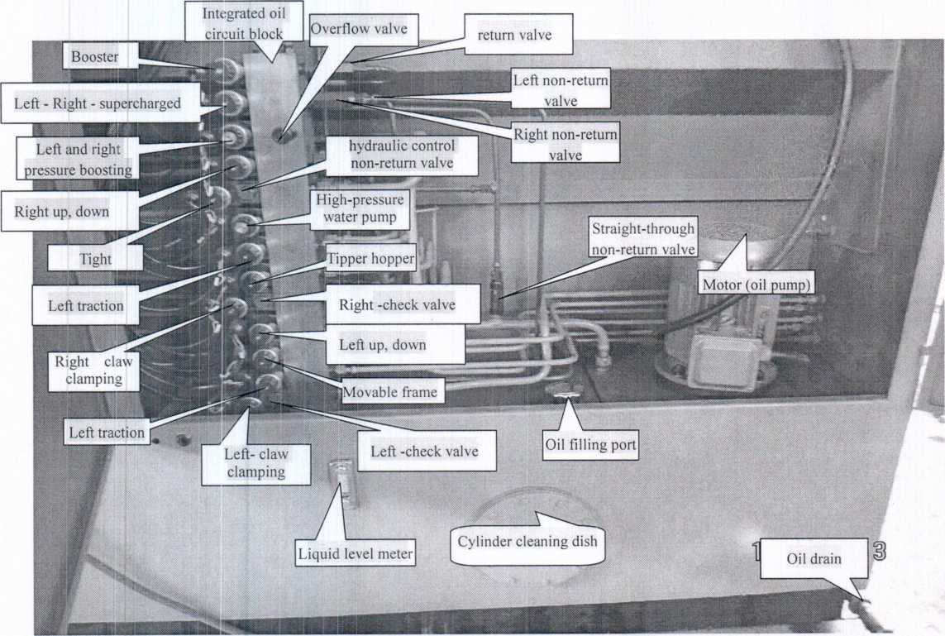
Figure 5
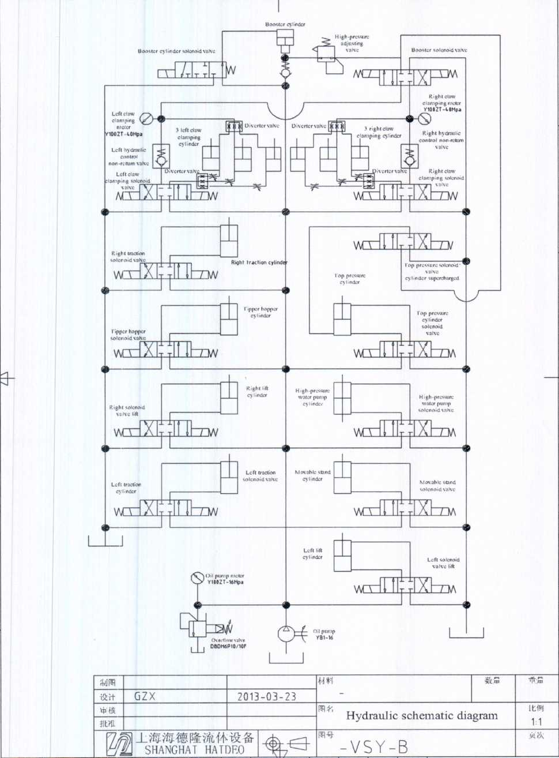
Fieure 6
3.4 Conditions, names, models and applications of hydraulic parts

SN | Conditions |  | Names | Models | Applications
1 | Left traction |  | Solenoid valve | 4WE6E60/E  G24NZ5L | Left claw forward and backward
2 | Left claw clamping |  | Solenoid valve | 4WE6E60/E  G24NZ5L | Axial movement of left claw cylinder
3 | High-pressure water pump |  | Solenoid valve | 4WE6E60/E  G24NZ5L | High-pressure water pump operation
4 | Right claw clamping |  | Solenoid valve | 4WE6E60/E  G24NZ5L | Axial movement of right claw cylinder
5 | Left and right pressure boosting |  | Solenoid valve | 4WE6E60/E  G24NZ5L | Left and right switching of booster cylinder oil
6 | Right pressure maintaining |  | Hydraulic control non-return valve | Z2S6A-40-6X | Pressure retaining valve of right claw clamping cylinder
7 | Pressure regulation |  | Overflow valve | DBDH6P10/10F | Regulation of oil pump pressure
8 | Pressure regulation |  | High-pressure regulating valve | YF-L8H4-S | Boost pressure regulation
9 | Right traction |  | Solenoid valve | 4WE6E60/E  G24NZ5L | Right claw forward and backward
10 | Tipper hopper |  | Solenoid valve | 4WE6E60/E  G24NZ5L | 90-degree overturning of right bench
11 | Booster cylinder |  | Solenoid valve | 4WE6D/E G24 | Booster cylinder operation
10 | Left pressure maintaining |  | Hydraulic control non-return valve | Z2S6B-40-6X | Pressure retaining valve of left claw clamping oil
13 | Movable frame |  | Solenoid valve | 4WE6E60/E  G24NZ5L | Left bench movement
14 | Non- | -return valve | Straight non-return valve | DIF-L10H | Oil supply of booster cylinder
15 | Non-return valve (1 ) |  | Left non-return valve | Self-manufactured | Pressure retaining valve of left claw clamping cylinder
16 | Non-return valve (2 ) |  | Right non-return valve | Self-manufactured | Pressure retaining valve of right claw clamping cylinder
17 | Non-return valve (3 ) |  | Right non-return valve | Self-manufactured | Top tight cylinders check valve
18 | pressure maintaining |  | Hydraulic control non-return valve | Z2S6A-40-6X | Top tight cylinders check valve
19 |  | Tight | Solenoid valve | 4WE6E60/E  G24NZ5L | Top tight cylinder - run
20 | Left up, down |  | Solenoid valve | 4WE6E60/E  G24NZ5L | Lift cylinder run
21 | Right up, down |  | Solenoid valve | 4WE6E60/EG24NZ  5L | Lift cylinder run

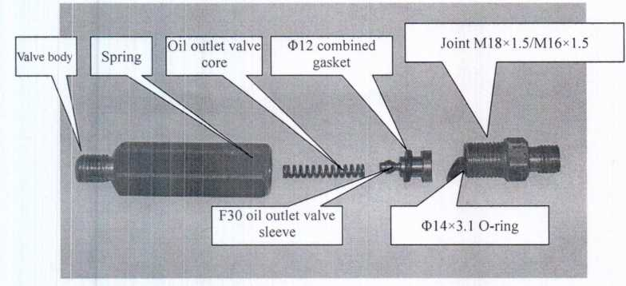
Figure 7
Disassembly and assembly diagram or hydraulic control non-return valve (Z2b6A-66/l-)
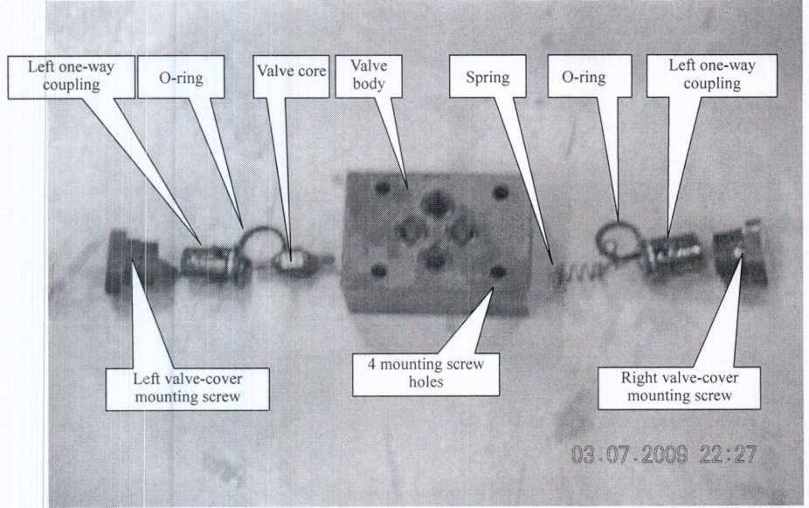
FigurS
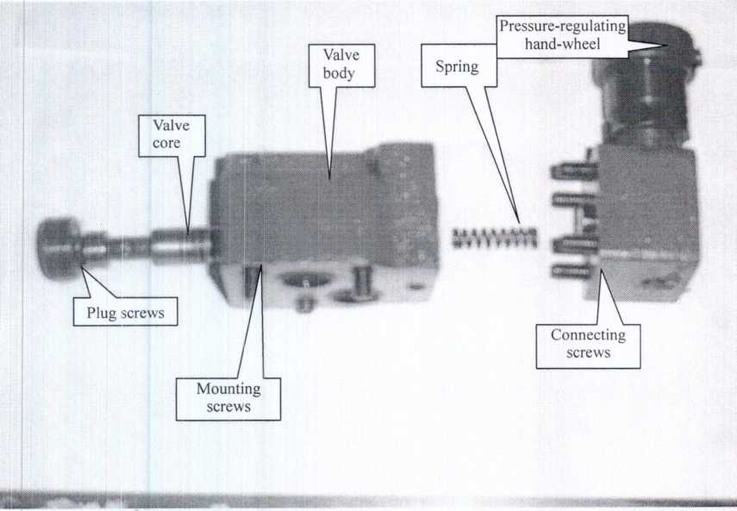
Figure 9
Solenoid valve structure diagram (4WE6E60/EW220RNZ5L)
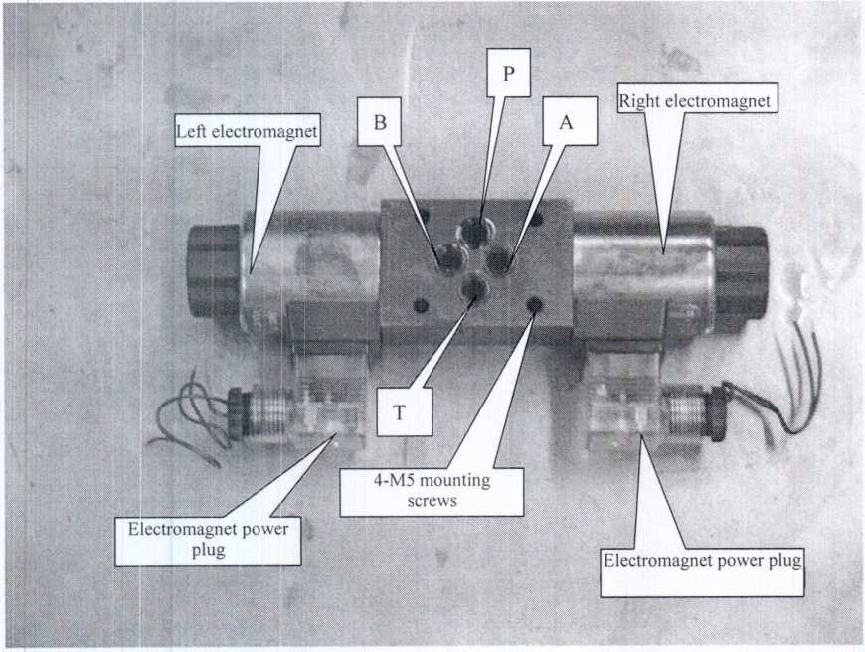
Figure 10

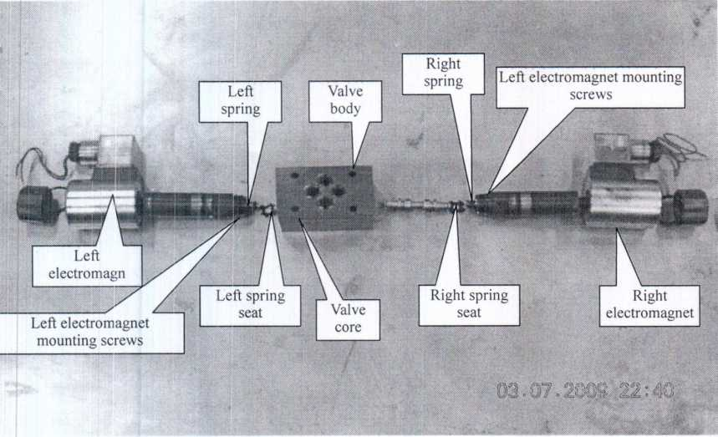
Figure 11
4. Low and High Pressure Pumps
- Structure diagram
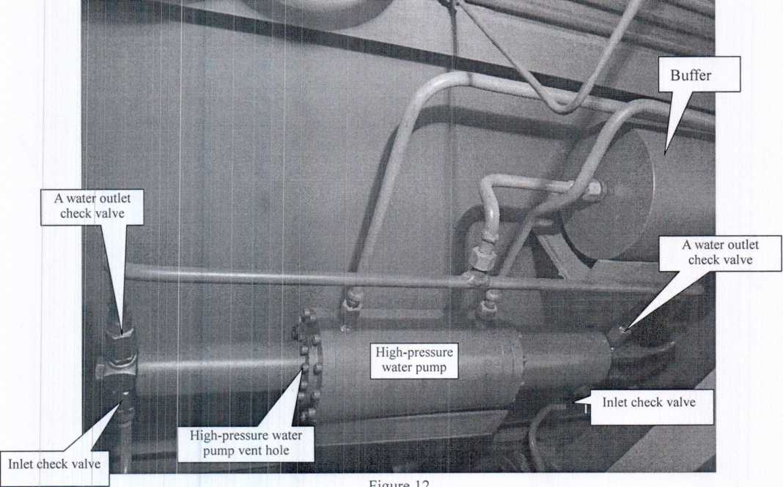

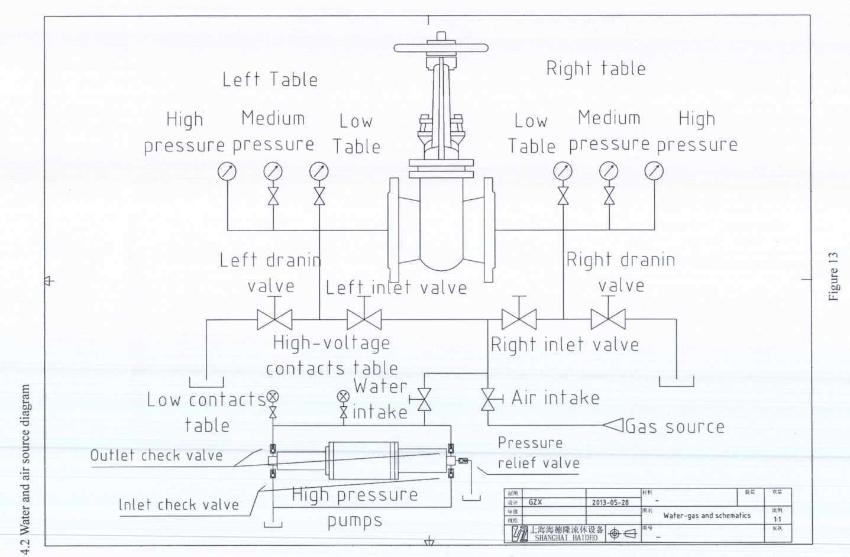

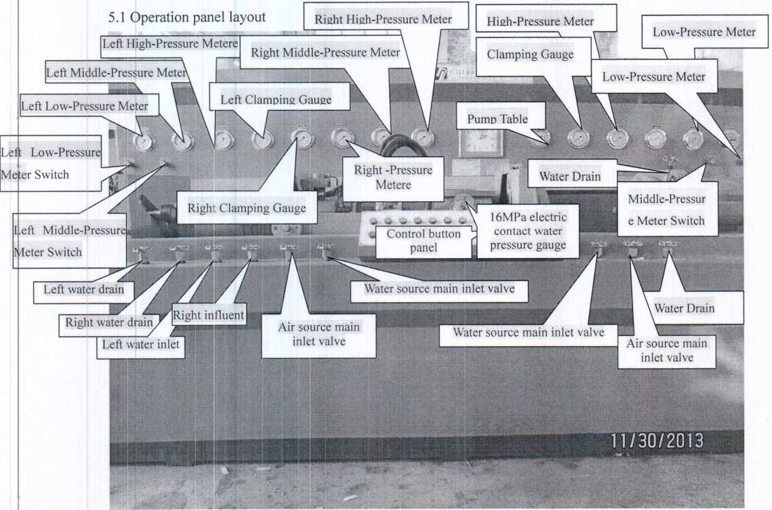
Figure 14
5.2 Operating instructions 1. Air and water needle valve
- Air source main inlet valve: when the test valve medium is air, open this valve and close the water source main inlet valve.
- Water source main inlet valve: when the test valve medium is water, open this valve and close the air source main inlet valve.
- Left water inlet: supply water at the left end of the tested valve (supply water at the left end when the medium is water; and supply air at the left end when the medium is air).
- Right water inlet: supply water at the right end of the tested valve (supply water at the right end when the medium is water; and supply air at the right end when the medium is air).
- Left water drain: release the pressure (air and water) in the tested valve at the left end.
- Right water drain: release the pressure (air and water) in the tested valve at the right end.
- ) Left Low-Pressure Meter Switch:: Over-range, turn off the switch
- ) Left Middle-Pressure Meter Switch: Over-range, turn off the switch 9) Right ow-Pressure Meter Switch: Over-range, turn off the switch
10 ) Right Middle-Pressure Meter Switch: Over-range, turn off the switch
- 16MPa electric contact water pressure gauge switch: close this valve when the test valve medium
is water and the pressure is equal to or more than 16MPa.
- High-pressure regulating valve: control the voltage increase to be within 5-31,5MPa.
2. Pressure gauge (the included pressure gauge shall be delivered by the user to the local quality
inspection department for inspection)
- Left claw clamping meter: pressure in the left three cylinders. Lift cylinder run
- Right claw clamping meter: pressure in the right three cylinders.
- Left low, medium, high table: pressure in the tested valve cavity.
- Right low, medium, high table: pressure in the tested valve cavity.
- Electric contact water pressure gauge 16MPa: stop the high-pressure pump and adjust the red gauge hand to the required pressure of the tested valve.
- Electric contact water pressure gauge 40MPa: stop the high-pressure pump and adjust the red gauge hand to the required pressure of the tested valve.
- Oil pump meter: oil-pump pressure.
- Low, medium, high table: pressure in the tested valve cavity.
- Pump Table: Hydraulic system working pressure
- Clamping table: Top pressure cylinder pressure
- Button panel (see Figure 14)
- Left claw forward: the left three cylinders radially run and shrink.
- Left claw backward: the left three cylinders radially run and expand.
- ) Left claw clamping: the left three cylinders axially run inside the cylinder.
- ) Left claw relax: the left three cylinders axially run outside the cylinder.
- ) Movable frame forward: the left clamping mechanism linearly runs towards the right clamping
mechanism.
- Movable frame backward: the left clamping mechanism reversely and linearly runs.
- Turn up: the right clamping mechanism turns up at 90°.
- Turn down: the right clamping mechanism resets.
- Right claw forward: the left three cylinders radially run and shrink.
- Right claw backward: the right three cylinders radially run and expand.
- Right claw clamping: the right three cylinders axially run inside the cylinder.
- Right claw relax: the right three cylinders axially run outside the cylinder.
- Left pressure increase: the pressure in the left three cylinders shall be increased, and the maximum pressure is 0.5-31.5MPa.
- Right pressure increase: the pressure in the right three cylinders shall be increased, and the maximum pressure is 0.5-31.5MPa.
- Host Up: Host rise to a straight line running
- Host Down: Host runs straight down
- Oil pump start: the oil pump runs.
- Oil pump stop: the oil pump stops running.
- Water pump start: the water pump runs.
- Water pump stop: the water pump stops running.
- Indicator Light: Power indicator
- Increase Pressure: Top tight cylinder - Cylinder fill pressure
- ) Tight: Left side - run
- ) Relax: Right side - run
- Host Up: Host rise to a straight line running
- Host Down: Host runs straight down
- Operating methods
  - Pre-start preparations
- Connect the power and enable the voltage to conform to the specified machine voltage as per the electrical system requirements.
- Check all buttons and electrical connections for damage or malfunctions, and set each switch to the “OFF” position.
- Check each change-over valve electromagnet for flexible operation.
- Check the bolts at all parts for tightening.
- After the cylinder is cleaned, add the cleaning operating oil of about 200L in the cylinder.
- YB-N32, YB-46 anti-wear operating oil shall be recommended for this machine.
- Completely clean the oil seal and dirt on the machine, and fill the lubricating grease and lubricating oil at the sliding parts and lubricating points.
  - Idle running test
- Connect the power, start the motor and oil pump, check the motor for correct rotation direction, enable the oil pump to be operated for above 5 minutes at unloading conditions, reuse the oil pump in case of first startup or long-term shutdown of the machine, and rotate the pump shaft by hands for more than ten rounds prior to startup in order to make the oil pump to be fully lubricated.
- After the oil pump is correctly operated, the air in the system will be completely discharged in case of whole-stroke forward and backward movement of the hydraulic cylinder and lower setting pressure, adjust the overflow valve (the right-handed rotation pressure of the overflow valve handwheel is high and the left-handed rotation pressure is low, see Figure 4), regulate the oil pump pressure to be 5Map, as shown in the oil pump meter, and adjust the rated oil pump pressure to be б.ЗМРа.
- Conduct trial running in the hand operation mode, and check for normal operations.
- Shutdown steps, including general shutdown and emergency shutdown.
Oil pump stop - operation.
Disconnect the master power switch.
In case of emergency shutdown, press the power switch button, the motor-oil pump will immediately stop running.
  - Other precautions
- In case of machine faults, the master power shall be disconnected, and buttons on the operation panel and master switches shall be set at the “OFF” position.
- During operation, the motor temperature shall not exceed 75 °C, or else shutdown inspection will be conducted.
- The machine shall be reliably grounded and the grounding resistance should be less than 10Г2 to prevent electric shock accidents.
  - Testing
- Clamping of tested valves Right clamping
Adjust left and right seal disks, place the flange surface at one end of the tested valve at the seal disk center of the right claw clamping bench of the test machine, jog (right forward) the button until the three clamping cylinder piston rods get close to 5-10/mm of the flange excircle of the tested valve; and press (right claw clamping) the button until the right claw clamping meter and the oil pump meter are equal or not increased, check the clamping cylinder comparison table, choose PN for seal test and choose PS for strength test, and press the (left pressure increase) button until the left claw clamping mater pressure increases the chosen PN and PS values.
- Left clamping
After right claw clamping, press the (movable frame forward) button, until the seal disk on the left clamping mechanism is adhered on the flange surface at the left side of the tested valve, and the following shall be completed with the right claw clamping steps.
- Shell test
After left and right claw clamping, adjust the electric contact pressure gauge, close the air source inlet valve, left water drain valve, right water drain valve, and disconnect the pressure gauge switch, open the water source inlet valve, left water inlet valve and right water inlet valve, and press the (water pump start) button. Start the low-pressure water pump, and automatically switch to the high-pressure water pump after the water pressure reaches the value set in the low-pressure electric contact pressure gauge (the highest pressure is generally set as 13kg), and the machine will automatically stop after reaching the value set in the low-pressure electric contact pressure gauge. Open the left water drain valve and the right water drain valve after testing, and press the “left claw relax - left claw backward - frame backward” button after the electric contact pressure is zero.
- Sealing test
Close the tested valve after shell test, and close the water source inlet valve, the right water drain valve and the left water inlet valve when the medium is air. Open the air source inlet valve and the right water inlet valve, and turn on the pressure gauge switch, press the (turn up) button, fill clean water at the left end of the tested valve after the right claw clamping mechanism turns over at 90 degrees, and observe the sealing performance and air bubbles in the tested valve. Close the air source inlet valve and open the right water drain valve after testing, and press the (right claw relax and right claw backward) buttons and remove the valve after the right pressure gauge is zero.
- Close the air source inlet valve, the right water drain valve and the left water inlet valve, and turn on the pressure gauge switch when the sealing test medium is water, open the water source inlet valve and the right water inlet valve, and press the (water pump start) button for visual inspection.
- Air sources shall be provided by the users.

6. Maintenance
6.1 Low-pressure water pump (see Figure 11)
 | Faults | Causes | Troubleshooting Methods
Suction failure of pump |  | 1. The motor does not work. | Check the circuit.
 |  | 2. The motor reversely rotates. | Interchange the incoming power lines and correct the motor rotation direction.
 |  | 3. The water level is inadequate, and the filter is blocked. | Fill clean water and clean the filter.
Failure to build-up pressure |  | 4. There is air in the pump. | Loosen the bleed screws for air exhaust during operation of the pump.
 |  | 5. The non-return valve is pressed. | Check and replace.
 |  | 6. The pipeline is blocked. | Dredge the water inlet pipeline.
 |  | 7. The clearance of all parts is over large caused by mechanical wear after long-term operation of the oil pump. | Replace the worn impeller.
 |  |  | Adjust and replace the impeller with over large clearance.
 |  | 8. The valve body leaks water. | Replace the O-ring.
 |  | 9. The machine seal leaks water. | Replace the machine seal.

6.2 High-pressure water pump
I | •aults
In-operation of water pump |  | 1. Low voltage electric contact pressure gauge (see Figure 11) | Check whether the low-pressure water pump has the rated pressure (1.3MPa).
 |  |  | Check whether the red needle of the low-voltage electric contact pressure gauge is higher than that of the high-pressure electric contact pressure gauge.
 |  | 2. High pressure water pump solenoid valve (see Figure 5) | Check whether the high-pressure water pump solenoid valve is normal.
 |  | 3. Over low oil pump pressure | Adjust the oil pump pressure reference values (Page 19).
Failure to exert pressure of water pump |  | 1. Suction failure | Check the water inlet pipeline.
 |  | 1. Suction failure | Check the suction non-return valve for water leakage, replace the О-rings and clean.
 |  | 1. Suction failure | Check the water outlet non-return valve A for water leakage, replace the О-rings and clean.
 |  | 2. Failure to maintain pressure | Check the water outlet non-return valves A and В for water leakage, replace the O-rings and clean.
 |  | 2. Failure to maintain pressure | Check left and right water drain valves for water leakage, close, and replace.
 |  | 2. Failure to maintain pressure | Check the air source main inlet valve for water leakage, close and replace.

Check and replace the damaged seal disk O-rings.
  - Common faults and troubleshooting
Fa
ult  s |  | Causes |  | Troubleshooting Methods
 |  |  | 1. Air enters into the hydraulic system, and the cylinder | 1. Loosen the cylinder joint, repeatedly operate the
Cy |  |  | occurs stop-and-go and continuous vibration phenomena. | cylinder, and exhaust the air.
lin  der | X  *<  а*  —t  р |  | 2. The system pressure is lower than the frictional resistance. | 2. Adjust the pressure required for the system.
Cr | i-  о‘ |  | 3. The cylinder and valve are not sealed with air. | 3. Replace the sealing elements.
ее | сл  CD |  |  | 4. Adjust the throttle valve at the bottom surface of
pa  ge | 3 |  | 4. Several clamping cylinders are asynchronous. | all clamping cylinders (the right-handed rotation valve is closed, and the left-handed rotation valve is opened).
 |  |  | 1. The valve core is pulled or blocked. | 1. Clean and grind.
 |  | О  =г | 2. The control oil tube is blocked. | 2. Dredge the control oil passage.
О | в.  <  а> | JQ  а>  ■  о  <  о  >-1 | 3. The reversal operation is not flexible and the valve core cannot be reset. | 3. Check and clean.
3  О.  CD |  |  | 4. The electromagnet mounting screws are loosened. | 4. Relock the mounting screws.
*TJ  p | m |  | 1. The electromagnet coil insulation is poor. | 1. Replace the electromagnet.
С  n> | а>  о |  | 2. The electromagnet door core is polluted. | 2. Sand and clear.
 | о  р  43 |  | 3. The control button is damaged. | 3. Replace again.
 | р  3 |  | 4. The voltage is incorrect, and the line is not powered on. | 4. Correct the voltage and check the line.
 | о  а> |  | 5. The wire joint is loosened. | 5. Reconnect the wires.
 | >Т! |  | 1. The hydraulic control non-return valve core is polluted and blocked. | 1. Check and clean.
 | р,  с  п>  О |  | 2. The sealing surface of the hydraulic control non-return | 2. Check, clean and replace.
 | 3  р. |  | valve is worn.
 | В.  5‘  тз  *-1  CD |  | 3. The non-return valve core is damaged. | 3. Check and replace. (Diesel engine delivery valve coupling F30)
CO  О  о  сл  пГ | оо  сл  С  ►ч  О |  | 4. The non-return valve spring is deformed. | 4. Replace.
О  М. |  |  | 5. The connection joint leaks oil. | 5. Check and replace O-rings.
3  О.  а>  “-S |  |  | 1. The control booster cylinder and left and right booster
 | й.  с* |  | change-over solenoid valves are out of control. | 1. Check and replace the failed cylinder.
 | *4  а*  о  5’  о |  | 22. The sealing elements of the booster cylinder are damaged. | 2. Replace.
 | а>  Р  сл  П)  тз  —S  п> |  | 3. The conical surface of the high-pressure regulating valve is damaged. | 3. Thin, clean and replace.
 | СЛ  сл  С  *1 |  | 4. The straight-through non-return valve is worn. | 4. Thin, clean and replace.
 |  |  | 5. The booster control button is damaged. | 5. Replace and check the line.
 | сл  с  о | 1. The motor rotation directions are reverse. | 1. Replace the incoming power lines, and correct the motor rotation direction.
 | о  р  Нь | 2. The cylinder level is too low and the oil cannot be | 2. Regularly check the oil level in the cylinder, and
 | С*  R | absorbed. | fill oil to the level.
 | О  рь |  | 3. Replace the oil with low viscosity (46 # anti-wear
 | с  3 | 3. The oil viscosity is too high. | hydraulic oil is recommended).
 |  | 4. The coupling key is worn. | 4. Check and replace.
 |  | 1. The cylinder oil level is decreased to enable the oil filter to be exposed to the oil level and inhale air. | 1. Fill the clean hydraulic oil.
 | fc  op' | 2. The oil filter is blocked. | 2. Clean and replace.
 | sr  3  о_  сл"  О)  р  3  о.  с  3  сл  р | 3. The clearance of all parts is over large caused by mechanical wear after long-term operation of the oil pump. | 3. Remove the pump for repair, fine grind the oil distribution disk panel, and replace the rotors, stators and blades.
 | а;  3“ | 4. The oil viscosity is too high. | 4. Use the oil with recommended viscosity.
 | о  сл  сл | 5. The oil seal at the pump shaft end or the O-rings in the | 5. Remove the pump and replace the oil seal and the
 | 3  Н  CD | pump body are damaged. | O-rings.
o |  | 6. The pump resonates with other equipment, and collides with the pipe. | 6. Separate longer oil tubes.
43  с  3  43 |  | 1. The pump fails to absorb oil. | 1. Refer to the measures listed for the pump fail to absorb oil.
 |  | 2. The oil is used for a long term, and has no viscosity. | 2. Replace the clean hydraulic oil.
 | *П  Р₄ | 3. The oil pump outlet pipe leaks oil. | 3. Replace the O-rings of the oil outlet pipe joint.
 | -t  О) | 4. The valve core is blocked at the “Normal Open”
 | а*  с | position, and the output oil of the oil pump cannot | 4. Eliminate the blockage failure.
 | Q-  С | flow into the system.
 | сл  v; | 5. The overflow valve core has burrs and dirt. | 5. Check, trim, grind and clean.
 | с?  3  43  ■1  а»  сл | 6. The fit clearance of the overflow valve core and the valve body is over large. | 6. Replace the valve core and adjust the clearance.
 | сл  С  И  CD | 7. The overflow valve springs are deformed and cannot be reset. | Check and replace the springs.
 |  | 8. The damping holes on the overflow valve core are | 8. Pass through the valve core damping holes
 |  | blocked with dirt. | with<I>lmm steel wires, and clean.
6.4 Hydraulic device maintenance
Inspection  Elements |  | Inspection  Items | Inspection Methods (measuring instrument name) | Circle | During  Inspection |  | Maintenance  Requirements | Repair (Replacement) Requirements
 |  | Inspection  Items | Inspection Methods (measuring instrument name) | /  Period | Start  up | Shut  dow  n | Maintenance  Requirements | Repair (Replacement) Requirements
 | Motor
w | Control
о  o' | electrical |  | Measure with |  |  |  | The insulation resistance with | Observe relevant motor
>  T3 | appliance | Insulation | 500V | 1/year |  | V | the grounding wire should be | standards and
§ | s |  | megohmmeter. |  |  |  | more than 1 OMn. | requirements.
CD  СЛ | Transfer  mer
 |  | Oil mass | Observe the liquid level meter. | I/day |  | V | Placed between the liquid level meter.
 | Hydraulic  oil | Oil  temperature | Thermometer on the liquid level meter | I/day | л/ |  | Within 20'C to 55'C
 |  | Cleanliness |  | 1/3  months |  | V | Follow the hydraulic oil standards and provisions.
 | Pressure  gauge | Pressure  measureme  nt | Metering | 1 /year | V | V | Local Bureau of Weights and Measures | Check for the unqualified parts and replace.
 |  | Operating  sound | Hearing | 1/day | V |  | No abnormal sounds. | Check and repair.
S3 | Solenoid  valve | Valve core wear | Valve core clearance | 1/year |  | V | No wear on surface | Replace the severely worn parts.
a.  3  c | Solenoid  valve | Screw  loosening | Mounting screws | 1/3  months |  | V |  | Install the loosened screws.
o‘  Ш  cT  3  CD  3 | Solenoid  valve | Screw  loosening | Electromagnet  screws | 1/3  months |  | V | Failure to loosen all parts | Install the loosened screws.
!» |  | Control line | Visual inspection | 1/3  months |  | V | No exposed stubs and surface damage | Wrap with insulating tapes and replace.
 |  | Operating | Check the | 1/3 | V |  | Follow the design | Check for malfunction
 |  | conditions | operation stability. | months | V |  | requirements. | and repair.
 | Oil  cylinder | External  leakage | Visual inspection and touch | 1/3  months | V |  | No leakage of all parts | Check and replace the sealing elements.
 | Oil  cylinder | Internal  leakage | Piston seal leakage | 1/3  months | V |  | Follow the cylinder operation requirements. | Replace the aged sealing elements.
 |  | External  damage | Visual inspection and touch | 1/3  months | V |  | No damage | Replace the damaged part.
 | Hose | Oil leakage | Visual inspection and touch | 1/3  months | V |  | No oil leakage | Repair and replace the О-rings with oil leakage.
 |  | Distortion | Visual inspection | 1/3  months | V |  | Failure to distortion | Distort and correct in time.
- Comparison table of wearing parts VSY-ABC-80
Product Names |  | Number of oil cylinders |  | Names | Models and Specifications | Quantities | Names | Models and Specifications | Quantitie  s
Clamping Cylinder |  | 6 |  | Sealing  elements | YX/D80 | 12 | O-ring | Ф80ХЗ. 1 | 6
 |  |  |  | Sealing  elements | YX /d50 | 6 | O-ring | Ф55ХЗ. 1 | 6
 |  |  |  | Sealing  elements |  |  | O-ring | Ф35ХЭ. 1 | 6
Traction Cylinder |  | 2 |  | Sealing  elements | YX /D50 | 4 | O-ring | Ф45ХЗ. 1 | 2
 |  |  |  | Sealing  elements | YX /d30 | 2 | O-ring | Ф35ХЗ. 1 | 2
 |  |  |  | Sealing  elements |  |  | O-ring | Ф 20 X 3. 1 | 2
Adjustable Shelf Cylinder |  | 1 |  | Sealing  elements | YX /D50 | 2 | O-ring | Ф45ХЗ. 1 | 1
 |  |  |  | Sealing  elements | YX /d30 | 1 | O-ring | Ф 35X3. 1 | 1
 |  |  |  | Sealing  elements |  |  | O-ring | Ф20ХЗ. 1 | 1
Tipper Hopper Cylinder |  | 1 |  | Sealing  elements | YX/D50 | 2 | O-ring | Ф45ХЗ. 1 | 1
 |  |  |  | Sealing  elements | YX /d30 | 1 | O-ring | ФЭ5ХЗ. 1 | 1
 |  |  |  | Sealing  elements |  |  | O-ring | Ф 15X3. 1 | 1
High-pressure Water Pump |  | 1 |  | Sealing  elements | YX /D140 | 2 | O-ring | Ф 135X3. 1 | 1
 |  |  |  | Sealing  elements | YX /D80 | 2 | O-ring | Ф 45 X 3. 1 | 1
 |  |  |  | Sealing  elements | YX/D55 | 2 | O-ring | Ф 35 X 3. ! | 1
 |  |  |  | Sealing  elements | YX /d40 | 2 | O-ring
Booster Cylinder |  | 1 |  | Sealing  elements | YX/D120 | 1 | Sealing  elements | YX/D40 | 1
 |  | 1 |  | Sealing  elements | YX/D100 |  | Sealing  elements | Ф 100X3. 1 | 1
 |  |  |  |  | YX /d60 |  | Sealing  elements | Ф65ХЗ. 1 | 1
 |  |  |  |  |  |  | Sealing  elements | Ф45ХЗ. 1 | 1

'п Й-iIE

Г¹ ПР45 1ЙПШ а
ШЧМ& VSY-ABC-80-160
ГВШ 2013 ^ ю Л
ГШ-Ц 1310018
L_l
