PECULIARITIES OF ALPHA FREQUENCY ACTIVITY IN VOLUNTARY RAT WHISKERS MOVEMENTS

L.A. Belichenko

A.B. Kogan Scientific Research Institute for Neurocybernetics,

South Federal University, Russian Federation.

Introduction.

Active sensory perception is often accompanied by motor ativity that can be of voluntary or non-voluntary character. In some animals, e.g. rats tactile perception is tightly linked to rhytmic movemwents of the vhiskers along surfaces or objects [8]. There exists a number of publications [9, 11] linking voluntary “feeling” movements of whiskers to background rhythms of the corticogram. Special attention is paid to background brain potentials in the theta and alpha frequency ranges due to importance of those rhythms in human and animal neural activity. The principal object of rhythmic alpha activity study are the so-called “sleep spindles” occurring in relaxed wakeful state as well as in early stages of natural or pharmacologically induced sleep. But we were not able to find any studies except [11] linking the spindle-form activity to whisker movement, originally demonstrated in [12]. The research goal is to find out general principles of alpha frequency activity during organization of voluntary whisker movement in rats.

Methods.

Microelectrode research of focal activity in separate sensomotor cortex barrels were conducted on rats partially immobilized by d-tubocurarine. Experiment methods received approval from the Bioethics Commission on the Russian Federation Academy of Sciences. The experiment preserved mobility of minor head muscles, including eye and whisker mucsles. Reginstarion of whisker movements was perfoemed by tensometric hair sensor. Background activity was registered using glass microelectrodes filled with 2,5 М NaCl solution. Electrodes were introduced into the somatic and motor cortex, in the whisker projection areas. Identification of the separate barrels in the somatic cortex was based on focal and pool activity in the somatic and motor cortex of the whisker projection areas. The location of an electrode in the somatic cortex was established by whisker movement in response to motor cortex stimulation. Subsequent analysis of the phase-frequency inter-zonal focal activity interaction was based on the power specters, coherency specters, phase specters and cross-specters. EEG filtration was used during data processing, utilizing digital filers of the MatLab 7.5.0 package.

Results.

The leading part in initialization and planning of voluntary movements is palyed by the premotor, frontal areas of the cerebral cortex. This is reflected by the appearance of premotor potentials and reorganization of the background EEG before the onset of voluntary movements [1, 5, 6]. In the relaxed wakeful state or light sleep voluntary movements of whiskers have been observed in rats on a background of spindle activity (Ill. 1). It must be observed that movements did not occur in the early part of a spindle, occurred in 10-30% cases during the middle part of the spindle and in 70-90% of cases during the terminal part. Our research and literature [3, 13] demonstrate that spindle activity is the reaction of cortical neurons to excessive hyperpolarization arising due to suppression of activating cholinergic and adrenergic reticulo-cortical inputs. An important part in this process is played by the so-called “pacemaker” or “membrane hyperpolarization-activated H-channels” [7, 10].
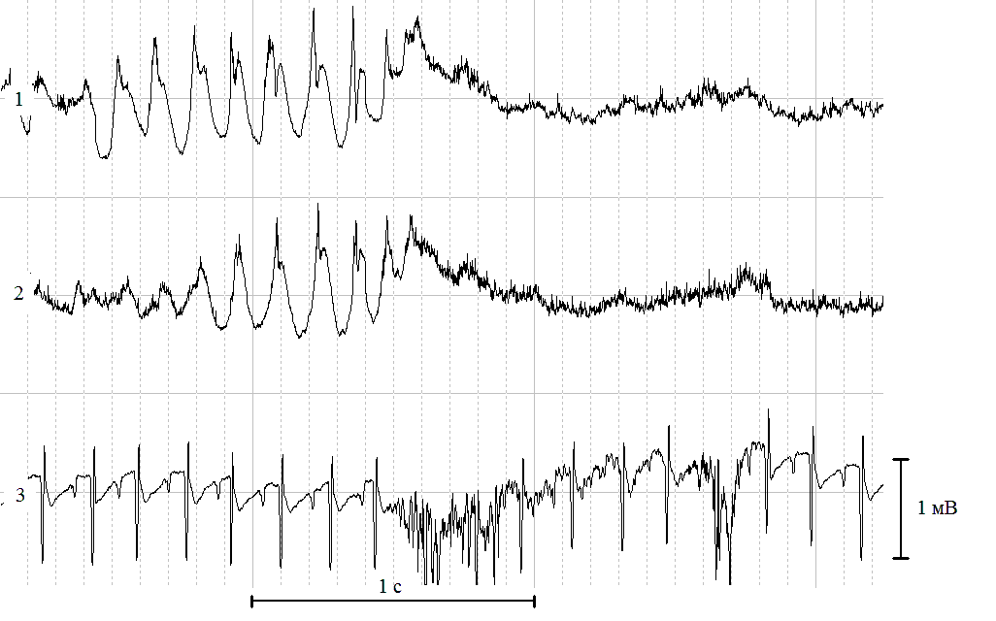
Illustration 1. Peculiarities of background spindle-shaped activity development before voluntary whisker movement in rats.
1 – sensory cortex activity
2 – motor cortex activity
3 – electromiogram of the cheek muscle pad and the ECG

Beside this, in 1-2 seconds before the voluntary movement in a number of cases rhytmic alpha-frequency discharges ended with a slow negative potential, so-called “readiness potential” or “E-wave”. So, before a voluntary movement on the background of alpha activity there occurs first, exit of neurons from the hyperpolarization state, and then increase in neural cell excitability, maybe caused by direct retuculo-cortical influences. This may be corroborated by the fact that in about 100 ms. before the movement occurs an increase in negativity is observed in both the cortex and in an number of cases, in the thalamic nuclei.
Before voluntary whicker movements in rats we have observed an increase in bioelectric activity synchronization in the alpha frequency specter that occurred exactly between various somatic cortex barrels, as well as between the cortex and thalamus. This means that not only local, but also distant synchronization of potentials developed as well. The research of M.N. Livanov showed that coordination of action between different brain structures necessitates joint tuning of their bioelectrical activity.
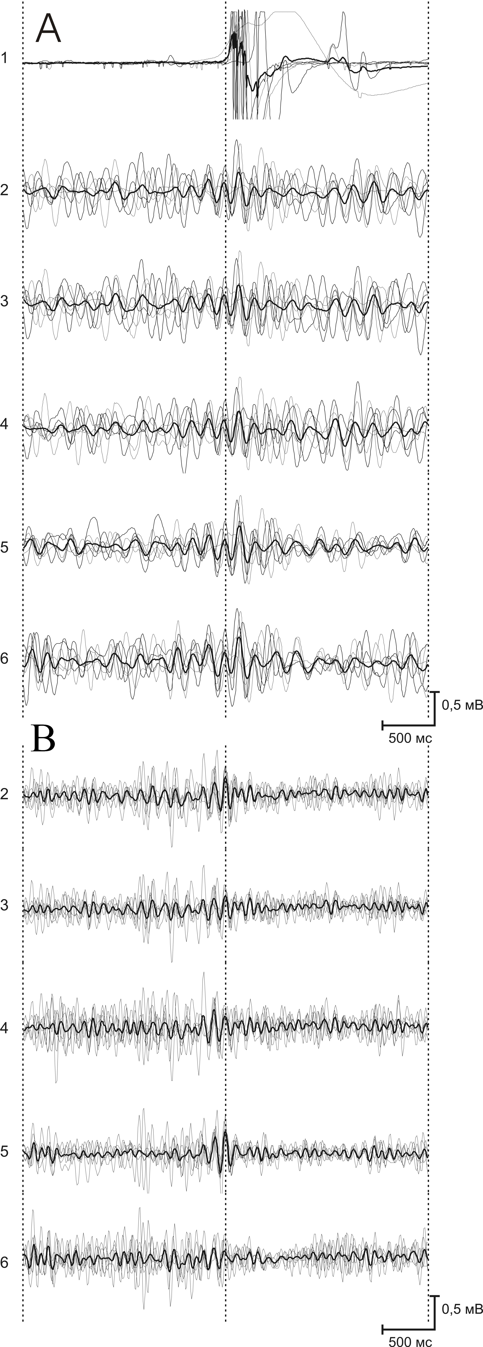
Figure 2 Phase dependence of initiation and development of voluntary movement on the background of theta (A) and alpha (B) frequency ranges.
Channel 1 – whisker movements;
Channels 2,3,4 – bioelectrical activity in the motor cortex;
5,6 – bioelectric activity of 2 barrels in the sensory cortex.
Records have been averaged (bold line) and synchronized to the onset of movement (dotted line).

In this regard we considered the possibility of phase dependence between local and distant synchronization related to voluntary movement. Ill. 2 shows several recordings of bioelectric activity with filtered theta (A) and alpha (B) rhythms for 2 seconds before and after onset of whisker movement. 2A shows, at about 500 ms before onset of movement, that all four channels of the theta rhythm demonstrated synchronous coincident development. It appears significant that the onset of movement coincides with the maximum of the negative phase, fourth wave. Maximal protraction (forward wisker movement) coincides with the fifth wave of the theta rhytm, which has the highest magnitude. The beginning of whisker retraction (movement back to the original position) corresponds to the сrest of the negative phase of the following theta wave. Further the rhythmic activity of varuios columns starts desynchronizing with the theta rhythm magnitude decreasing. In the sensory cortex (channels 5 and 6) this process occurs slower, synchronicity there persists for 700-800 ms. since onset of movement. This is probably related to the processing of signals received from the whisker movement. So, as seen from Ill. A, the development of voluntary movement is related to the maximum of the negative wave phase before movement, and the movement itself coincides with the negative wave of the highest magnitude, i.e. is phase-dependent. It is important to point out that in the case of preceding spindle-shaped activity the onset of movement coincides with the negative phase of the potential, being linked to the moment of maximal excitability of cortical barrels during the negative phase of the focal spindle activity potentials. After the movement the magnitude of spindles decreases sharply, as well as their level of synchronizations.
There is presently not many publications dedicated to relationships between the alpha rhytm and movement activity. Most fundamental and applied research deals with the relation of alpha rhytms to the perception, attention and memory. Our findings allow to suppose that the alpha rhytm participates in sensomotory interactions, which is suppoted by other researchers [4]. It may be possible that the appearance and development of a spindle till its maximal magnitude is related to processes of sensory information perception while the subsequent suppression before onset of movement indicates the activity of decision-making schemes. The local and distant synchronization observed facilitates the motor reactions to sensory stimulus in man and animals. The “E-wave” observed in a number of cases appears to us to be an addition method of increasing cortical neuron excitability by activating reticulo-cortical influences. This slow negative potential possibly corresponds to the decision-making moment and to initialization of voluntary movement with functional sensomotor integration.

Conclusions.
- In the relaxed wakeful state or light sleep the voluntary movements can be observed in the presence of background spindle-shaped activity. Voluntary movement in this state most frequently occur during the later phases of the spindle, which is related to restoration of initial excitability of cortical barrels caused by removal of excessive hyperpolarization of neurons during the spindle. Suppression of a spindle directly before a voluntary movement corresponds to the decision making process.
- Despite the different character of background bioelectric activity before movement, a significant fact is the correlation of movement onset with the development or increase of negative potentials which reflect the growth of excitability in neural cells. The slow pre-motor negative potential or “E-wave” is directly linked to the decision taking momeтt and initialization of the voluntary movement.
- Growing magnitude of spindle-shaped activity before movement, accompanied by local and distant synchronization between motor cortex, sensory cortex and thalamic nuclei corresponds to the afferent synthesis stage of a functional system activity according to P.K. Anоkhin.
- Sensory areas of the cortex participate not only in afferent information processing, but in activity planning and result forecasting as well. So, the sensory areas of the cortex manage the flow of sensory information to the motor cortex during the active feeling movements of the whiskers.
- The whiskers system is greatly influenced by the thalamocortical relations that take part not only in sensory information processing, but participate in generation of motor commands as well.
Literature.

- Батуев А.С., Таиров О.П. Мозг и организация движений. – Л.: Наука, 1978. - 140 с.
- Ливанов М.Н. Пространственная организация процессов головного мозга. Москва, Наука, 1972, 182 с.
- Сухов А.Г., Сердюк Т.С., Коняхина Л.А. Внутрикорковый механизм генергации веретенообразной активности в колонках соматической коры крысы// Вестник Южного научного центра РАН. – 2007. – Т.3. - №.2. – С. 86-94.
- Ahissar E, Haidarliu S, Zacksenhouse M. Decoding temporally encoded sensory input by cortical oscillations and thalamic phase comparators // Proc. Natl. Acad. Sci. U S A., 1997, v. 94, № 21, p. 11633-11638.
- Ahissar E., Kleinfeld D. Closed-loop neuronal computations: focus on vibrissa somatosensation in rat // Cerebral Cortex, 2003, v. 13, p. 53–62.
- Alloway K. D. Information processing streams in rodent barrel cortex: the differential functions of barrel and septal circuits // Cereb. Cortex, 2008, v. 18, № 5, p. 979-989.
- Bal T., McCormick D.A. What stops synchronized thalamocortical oscillations? // Neuron, 1996, v.17, № 2, p.297-308.
- Carvell G.E., Simons D.J. Biometric analyses of vibrissal tactile discrimination in the rat // J Neurosci., 1990, v. 8, p. 2638-2648.
- Ganguly K., Kleinfeld D. Goal-directed whisking increases phase-locking between vibrissa movement and electrical activity in primary sensory cortex in rat // Proc. Natl. Acad. Sci. USA, 2004, v. 101, № 33, p. 12348-12353.
- Pape H.C., McCormick D.A. Noradrenaline and serotonin selectively modulate thalamic burst firing by enhancing a hyperpolarization-activated cation current // Nature, 1989, v.340, №6236, p.715-718.
- Semba K., Komisaruk B.R. Neural substrates of two different rhythmical vibrissal movements in the rat // Neuroscience, 1984, v. 12, p. 761–774.
- Semba K., Szechtman H., Komisaruk B.R. Synchrony among rhythmical facial tremor, neocortical ‘alpha’ waves, and thalamic non-sensory neuronal bursts in intact awake rats // Brain Res., 1980, v. 195, № 2, p. 281-298.
- Timofeev I., Grenier F., Steriade M. Disfacilitation and active inhibition in the neocortex during the natural sleep-wake cycle: an intracellular study // Proc. Natl. Acad. Sci. USA, 2001, v. 98, № 4, p 1924-1929.

