The Ministry of Education and Science of Ukraine
The National Aerospace University named after N.Y.Zhuckovsky
“The KhAI”

Department 402

SPECIAL PART
to the diploma paper
ХАИ.461П.07.ДП.07.ПЗ.04.
The design of the cathode for the plasma-ion thruster’s ionizational chamber for the range of currents 1…10 amp.

Fulfilled by: student of the 461p gr.
A.P. Kirillova
__________________________
(signature, date)
Supervisor: candidate of technical science, associate professor of the 402 dep.
A.I. Oransky
__________________________
(signature, date)

2007
CONTENT

1. THEORETICAL INFORMATION. 3
1.1. THE PRINCIPAL SCHEME OF THE NON-INCANDESCENT HOLLOW CATHODES WITH THE EXTERNAL DISCHARGE INITIATOR. THE PROCESS, TAKING PLACE IN THEM. 3
1.2. REQUIREMENTS TO THE BASIC PARAMETERS OF THE HOLLOW CATHODE. 5
2. RECOMMENDATIONS TO THE BASIC CATHODE ELEMENTS’ MATERIALS SELECTION. 7
2.1. THE MAIN REQUIREMENTS TO THE EMITTER MATERIAL AND ITS SELECTION. 7
2.2. THE MAIN REQUIREMENTS TO THE DIELECTRIC MATERIALS AND THEIR SELECTION. 8
3. APPRICIATE CALCULATION OF THE GEOMETRICAL PARAMETERS OF THE WARMLESS CATHODE WITH EXTERNAL DISCHARGE INITIATOR. 11
4. DESIGN OF THE NON-INCANDESCENT HOLLOW CATHODE WITH THE EXTERNAL DISCHARGE INITIATOR. 13

1. THEORETICAL INFORMATION.

1.1. THE PRINCIPAL SCHEME OF THE NON-INCANDESCENT HOLLOW CATHODES WITH THE EXTERNAL DISCHARGE INITIATOR. THE PROCESS, TAKING PLACE IN THEM.

The general view of the non-incandescent hollow cathode with the external discharge initiator is shown in the fig.1:
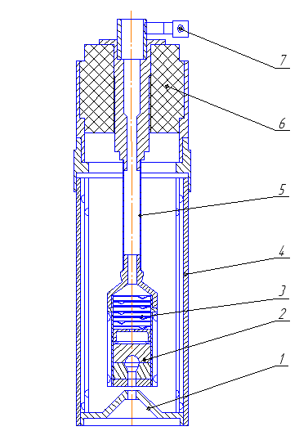
Fig.1. – The general view of the non-incandescent hollow cathode with the external discharge initiator. (1 – starter; 2 – emitter; 3 – set of the tantalum degasifiers; 4 – frame; 5 – gas-intake tube; 6 – isolator; 7 –contact)

The following peculiarities characterize the cathodes of this class:
- The working cavity availability. It is usually produced from the highly emitting material;
- The pressure of the plasma-generating gas required for the discharge maintenance is ensured with the permanent gas supply directly through the working hole.
- Operation in the automatic mode (i.e. cathode self-heating with the energy generated by the discharge itself) during the steady discharge stage;
- Necessity of the additional devices for the discharge initiation during the cathode activation.

In order to initiate the discharge in the non-incandescent cathodes the starter is usually used: the voltaic arc appeared between the starter and the cathode falls in the working cavity and heats the internal surface of the emitter. When the temperature reaches the operating temperature, the phenomenon of the thermoemission from the surface of the working hole occurs. The emitted electrons accelerate in the electrical field of the intermediate electrode (in this case – starter), come into collisions with the atoms of the neutral gas and ionize it. The avalanche-like process of the gas ionization takes place in the gas-discharge chamber; it leads to the initiation and development of the voltaic arc discharge initiation and development between cathode and anode. The electrons accelerated in the cathode electrical field spend part of their energy on the ionization and excitation of the running gas atoms. Plasma deionization occurs at the expense of the ionic and electronic recombination.
Positive ions moving to the cathode attack its working surface with the energy gained in the cathode potential drop. Further, radiant energy of the excited atoms and energy of the metastable electrons transfer on the cathode. That’s why the cathode temperature keeps on the required for the operation level without additional external heating, i.e. the cathode operates in the automatic mode.
At the expense of the thermodynamic extension and antipolar diffusion plasma from the active cathode zone gets into the external interelectrode space and forms the external positive column of the discharge. On the border with anode external positive column turns into the anode layer in which the electron acceleration from plasma to anode takes place.
The mechanism of the electronic emission from the gas discharge hollow cathode working surface is based on the thermoemission enforced by the Schottky effect. And the emissive ability defining factor is the work function of the emitters material.

1.2. REQUIREMENTS TO THE BASIC PARAMETERS OF THE HOLLOW CATHODE.

The basic parameters which characterize the operation efficiency of the gas discharge cathodes under consideration are:
- discharge current – $I_{D}$, amp;
- life time – τ, hours;
- specific energetic losses – $C_{e\text{.}l\text{.}}=\frac{W}{I_{D}}=\frac{I_{D}U_{\text{opt}}}{I_{D}}≡U_{\text{opt}}$, W/amp;
- gas efficiency – $С_{g}=\frac{І_{D}}{\overset{˙}{m}\left(\text{eq А}\right)}=\frac{I_{D}m_{w\text{.}b\text{.}}}{е\overset{˙}{m}}$, el/atom;
- cathode operational temperature – $T_{K}$, K;
- quality factor – $K_{e}=\frac{{ΔG}_{e}}{I_{D}τ}$, kg/coulomb;
- actuation time – $τ_{\text{act}}$, sec;
- parameters’ stability;
- operational features, chief dimensions and weight, fabricability, cost, etc.
Functional actuation time is the period in the cathode work which lasts from the moment of the start signal injection up to the moment when cathode’s basic functional parameter – main discharge current – reaches steady nominal value.
The term ‘start’ (full start) is the time from the moment of the injection voltage supplied to the moment when all operational processes parameters reach steady nominal value.
The rest of the parameters of the gas discharge hollow cathode are generally accepted. It’s worth to mention that the concrete conditions desire advanced requirements towards these or those cathode parameters. Thus while the cathode works in the electrorocket propulsion system of the artificial Earth satellite with the long term of the active operation the requirements of the great cathode life time (τ up to 10000 hours) and requirements of the high quality factor (K ‹ $5⋅{\text{10}}^{−3}$ kg/coulomb) become particularly important. Cathode block’ dynamical characteristics ($τ_{\text{act}}$ ≈ 0.1-1 sec) are determinative for the orientation system thrusters.
The requirements to the gas efficiency are particularly strict for the neutralizers (C_{g} › 20-50 el/atom).
The discharge current for the majority of the electrorocket thrusters’ cathode units is usually set. It is determined by the value of the thruster’s ion beam current.
The choice of the working body is also stipulated by the requirements to the entire propulsion system [2, 3]. Taking into account these requirements the best of the inert gases is xenon, which is usually chosen as the working body for the majority of the gas electrorocket thrusters.

2. RECOMMENDATIONS TO THE BASIC CATHODE ELEMENTS’ MATERIALS SELECTION.

2.1. THE MAIN REQUIREMENTS TO THE EMITTER MATERIAL AND ITS SELECTION.

Reasoning from the requirements to the basic cathode’ parameters, from the mechanism of the electronic emission and its working surface destruction, the main demands to the emitter’s material are:
- low effective work function;
- high thermochemical stability and basic parameters stability during the life time;
- high binding energy of the activational atoms with the working surface;
- high resistance to the residual gas etching;
- great storage factor, weight and volume concentration of the emissive compound;
- contact compatibility with constructional materials;
- high activating agent utilization ratio;
- electrical conduction;
- electronic emission and electrical resistance homogeneity;
- ability to preserve the geometry, dimensions during the life time.
Besides it is necessary to take into account the following:
- conditions of the cathode actuation, actuation time;
- possibility of the multiple exposure in the open air and reactivation after that;
- mechanical strength, stability of shape during operational mode and while transporting;
- manufacturability, fabrication and processing value;
Nowadays there is a series of the worked out cathode materials, which somehow or other satisfy the listed demands. They are:
- boride of the rare-earth metals;
- dispenser chamber and impregnated barium-containing cathodes;
- series of the refractory compounds of the metals of the transition groups of the periodic system with boron, carbon and nitrogen;
Following the listed recommendations select the spongy tungsten, impregnated by barium-calcium aluminate – W-3BaO-Al₂O₃-0.5CaO.

2.2. THE MAIN REQUIREMENTS TO THE DIELECTRIC MATERIALS AND THEIR SELECTION.

Ceramic elements which contact the metal details of the gas-intake tube, screens, body of the gas-discharge hollow cathode at temperatures 1000.. 2000 K, should not react with materials of these elements, as it results to metallization or other worsening of the insulating properties of ceramics, and as the result to the significant leakage current or to the bridging of electrodes.
The serious attention during a choice of ceramics in gas-discharge hollow cathode should be given to such of its properties as gas evolution and gas permeability of ceramics.
The main reasons of gas evolution of ceramic materials are desorption of gases which were absorbed during the manufacturing, and also the pressure of the saturated steam of components of ceramics. Gas evolution also depends from a condition of a surface, gas-saturated (in limits up to 20 microns) layers of ceramics.
Gas permeability of ceramic materials on basis of Al₂O₃ и BeO mainly is determined by its density. At porosity of 3..5 % they practically are impenetrable for the majority of gases down to the temperatures 1700..1800 K.
The connection of metals with ceramics nowadays is provided in two ways:
а) by soldering with preliminary metallization of ceramics;
б) by mechanical and chemical treatment of connected surfaces, and then by electron-beam and diffusion welding.
The solders used for the soldering, should satisfy to the following demands:
- provide joint efficiency at working temperature;
- moisten metal and metal covering good without interaction with them;
- must have a low yield point, low modulus of elasticity and high meaning of percent elongation, as in this case because of a flexibility of solder the stress relaxation take place, which occurs in ceramic-metal seals during the cooling of parts and fast heating of parts.
The solders used for the soldering of metal with ceramics, are made on the basis of silver, palladium, nickel, titanium etc. As high-temperature solders which don't interact with the material of ceramics and metal details at temperature 1200 K, eutectic Ni-Ti (30 percents by weight of Ni and 70 percents by weight of Ti) is recommended; at temperatures up to 1800..1900 K for ceramic-metal parts the alloy on a basis of vanadium and niobium (65 percents by weight of V, 30 percents by weight of Nb, 5 percents by weight of Ti) is recommended.
Recently an alloy of palladium with cobalt finds wide application (65 percents by weight of Pd and 34 percents by weight of Co) with melting temperature of 1523 K.
For strong connection of metal with ceramics it is necessary before the soldering to carry out metallization of a part of a surface of ceramics by metal compatible both with ceramics and with solder.
At working temperatures of metal-ceramic parts higher then 1300 K the role of metallized covering plays tungsten in the form of emulsion - 83 % of water and 17 % of tungsten. Ceramics after plating is annealed in the atmosphere of hydrogen at temperature 2000..2150 K. The bond resistance of metallized covering with ceramics is increased with increasing of the burning-in temperature and decreasing of size of tungsten's grain up to the sizes of 0,7.. 1,0 microns.
Metallic materials, from which the body of gas-discharge hollow cathode and current contact jaw are made, should satisfy the following demands:
- The coefficients of thermal expansion of metals should be coordinated with the coefficients of thermal expansion of ceramic materials;
- Good vacuum properties: gas permeability at small (0,2.. 0,5 mm) thicknesses, small steam tension and low speed of evaporation;
- High resistance to the ion dispersion (for the cathode casing).
Depending on the working temperature condition the listed details can be produced from conar, stainless and heat-resistant steel, molybdenum and its alloys, niobium and its alloys and other similar materials.

3. APPRICIATE CALCULATION OF THE GEOMETRICAL PARAMETERS OF THE WARMLESS CATHODE WITH EXTERNAL DISCHARGE INITIATOR.

Let’s consider the purpose of the geometrical characteristics calculation determination of the basic parameters of the cathode configuration. Initial data for the calculation are the following:
- electrical current from the cathode I_{e}=5 amp;
- emission current density j_{e}=$5⋅{\text{10}}^{5} \text{amp}m^{2}$;
- working body – xenon;
- emitter material – spongy tungsten.
Let’s evaluate necessary area of the emission cathode surface:
$$S_{e}=\frac{I_{e}}{j_{e}}$$ | (1.1)
$$S_{e}=\frac{1\text{.}\text{38}}{5⋅{\text{10}}^{5}}=0\text{.}\text{276}⋅{\text{10}}^{−5} m^{2}$$
Let the discharge chamber to be spherical. Then it is easy to calculate its radius:
$$r_{\text{sph}}=\sqrt{\frac{S_{e}}{4⋅π}}=\sqrt{\frac{0\text{.}\text{276}⋅\text{10}}{4⋅3\text{.}\text{14}}}=0\text{.}\text{959}⋅{\text{10}}^{−3} ( m)$$ | (1.2)
It is necessary also to calculate the radius of the diaphragm aperture r_{d}. let it be larger than some radius r_{d}* which may be determined from the equation 1.3:
$e⋅n_{e}⋅V_{e}⋅π⋅r_{d}∗I_{e}$ , | (1.3)
where e –electron charge, $e=1\text{.}6⋅{\text{10}}^{−\text{19}}$ coulomb;
n_{e} –electrons concentration, n_{e}=n_{i};
$$V_{e}≥\sqrt{\frac{k⋅T_{e}}{m_{e}}}$$ | (1.4)
where k – Boltzmann constant, $k=1\text{.}\text{38}⋅{\text{10}}^{−\text{23}} \text{joule}/\text{sec}$;
m_{e} –electron weight, $m_{e}=9\text{.}1⋅{\text{10}}^{−\text{31}} \text{kg}$;
Т_{е} –electron temperature, $T_{e}=\frac{e⋅ϕ_{i}}{3⋅k}$
where φ_{i} – ionization potential of the working body (here – xenon) φ_{i}=12.13эВ.
$$T_{e}=\frac{1\text{.}6⋅{\text{10}}^{−\text{19}}⋅\text{12}\text{.}\text{13}}{3⋅1\text{.}\text{38}⋅{\text{10}}^{−\text{23}}}=4\text{.}7⋅{\text{10}}^{4} (\text{deg})$$
Thus $V_{e}≈\sqrt{\frac{1\text{.}\text{38}⋅{\text{10}}^{−\text{23}}⋅4\text{.}6⋅{\text{10}}^{4}}{9\text{.}1⋅{\text{10}}^{−\text{31}}}}=0\text{.}\text{71}⋅{\text{10}}^{6}( m/\text{sec})$
The ion concentration and hence the electron concentration may be defined as follows:
$$I_{e}⋅ϕ_{w}=e⋅n_{i}⋅\sqrt{\frac{k⋅T_{e}}{m_{i}}}⋅S_{e}⋅\left(ϕ_{i}−ϕ_{w}+ϕ_{с}\right) , ϕ_{с}≈ϕ_{i}$$ | (1.5)
where φ_{w} – work function of the emitter material, for the spongy tungsten φ_{в}=2.2эВ;
m_{i} – working body ion weight (xenon), $m_{i}=\text{218}⋅{\text{10}}^{−\text{27}} \text{kg}$.
$$n_{i}=\frac{I_{e}⋅ϕ_{w}}{e⋅\sqrt{\frac{k⋅T_{e}}{m_{i}}}⋅S_{e}⋅\left(2⋅ϕ_{i}−ϕ_{w}\right)}$$
$$n_{i}=\frac{1\text{.}\text{38}⋅2\text{.}2}{1\text{.}6⋅{\text{10}}^{−\text{19}}⋅\sqrt{\frac{1\text{.}\text{38}⋅{\text{10}}^{−\text{23}}⋅4\text{.}7⋅{\text{10}}^{4}}{\text{218}⋅{\text{10}}^{−\text{27}}}}⋅0\text{.}\text{276}⋅{\text{10}}^{−5}⋅(2⋅\text{12}\text{.}\text{13}−2\text{.}2)}=1\text{.}\text{81}⋅{\text{10}}^{\text{20}} \left(\frac{1}{m^{3}}\right)$$
n_{i}=n_{e}
$$r_{d}∗\sqrt{\frac{I_{e}}{e⋅n_{e}⋅V_{e}⋅π}}=\sqrt{\frac{1\text{.}\text{38}}{1\text{.}6⋅{\text{10}}^{−\text{19}}⋅1\text{.}\text{81}⋅{\text{10}}^{\text{20}}⋅0\text{.}\text{71}⋅{\text{10}}^{6}⋅3\text{.}\text{14}}=}0\text{.}\text{75}⋅{\text{10}}^{−3} (m)$$

Therefore the radius of the diaphragm aperture consider being equal 0.75 mm.

4. DESIGN OF THE NON-INCANDESCENT HOLLOW CATHODE WITH THE EXTERNAL DISCHARGE INITIATOR.

The non-incandescent hollow cathode with the external discharge initiator design is shown on the drawing KhAI.402.461.06.00.00.ASSY.
The non-incandescent hollow cathode with the external discharge initiator consists of the three basic functional elements: the cathode itself, the starter and the insulator.
The cathode is the tube (cathode housing 11) where front 5 and back 6 parts of the emitter with the spherical working hole in them are situated. In order xenon to get to the working hole through the back part of the emitter on its lateral surface there are milled grooves which are directed to the center on its face, i.e. to the discharge chamber. Such construction also prevents electrical discharge expansion outside the discharge chamber from the gas intake side. On the left side in cathode casing the diaphragm 5 is mounted by the laser bonding. On the right by means of the connection pipe 12 the gas intake tube 13 is fastened. There is also set of tantalum degasifiers 22. Heated tantalum has the property to absorb different impurity substances containing in the working gas. In such way xenon purification is produced. The electricity is imposed to the cathode by means of the contact 17 through the center shaft 16 of the insulator and gas intake tube 13. From the outside the cathode casing is surrounded with the heat shield 10.
The starter 1 is fastened to the casing 2 by means of laser bonding. The electricity is transferred on it from the contact 17 along sleeves 14, 15 and casing 2. Casing has heat shields 3 and 4 inside it.
The insulator is 2 ceramic bushings (dielectrics 18), fitted on the insulator center shaft, and connection pipe 19 to which the gas intake tube 20 is fastened. In such way the electricity isolation of the cathode and starter, as well as, of cathode and external elements of the working body supply system is arranged.

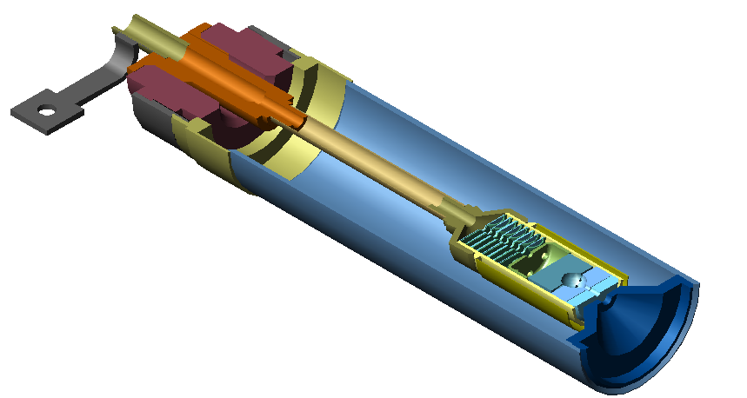
Fig. 2. − Nonincandescent hollow cathode.

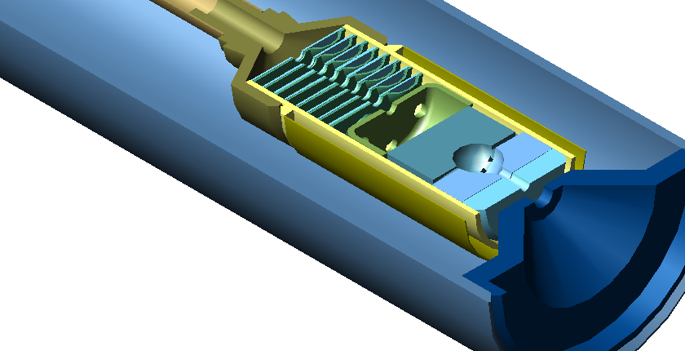
Fig. 3. − Emitter and the starter.

REFERENCES

- Архипов Б.А. Исследование и разработка катодов нового поколения для стационарных плазменных двигателей (СПД): Автореф. дис… д-ра техн.наук: 05.07.10 / МАИ. - М., 1998 . - 45 с.
- Owens W.Z. A Noble. Gas Ion Propulsion system. "AIAA Paper", № 73 - 1114, - 1973. - р.1 - 8.
- Finke R.C. and Murch O. K. Current technology in ion and. electrothermal propulsion. "AIAA Paper", № 73 - 1253, - 1973. - р. 14 - 19.
- Термоэлектронные катоды. Кудинцева Г. А. и др. М., 1966.

